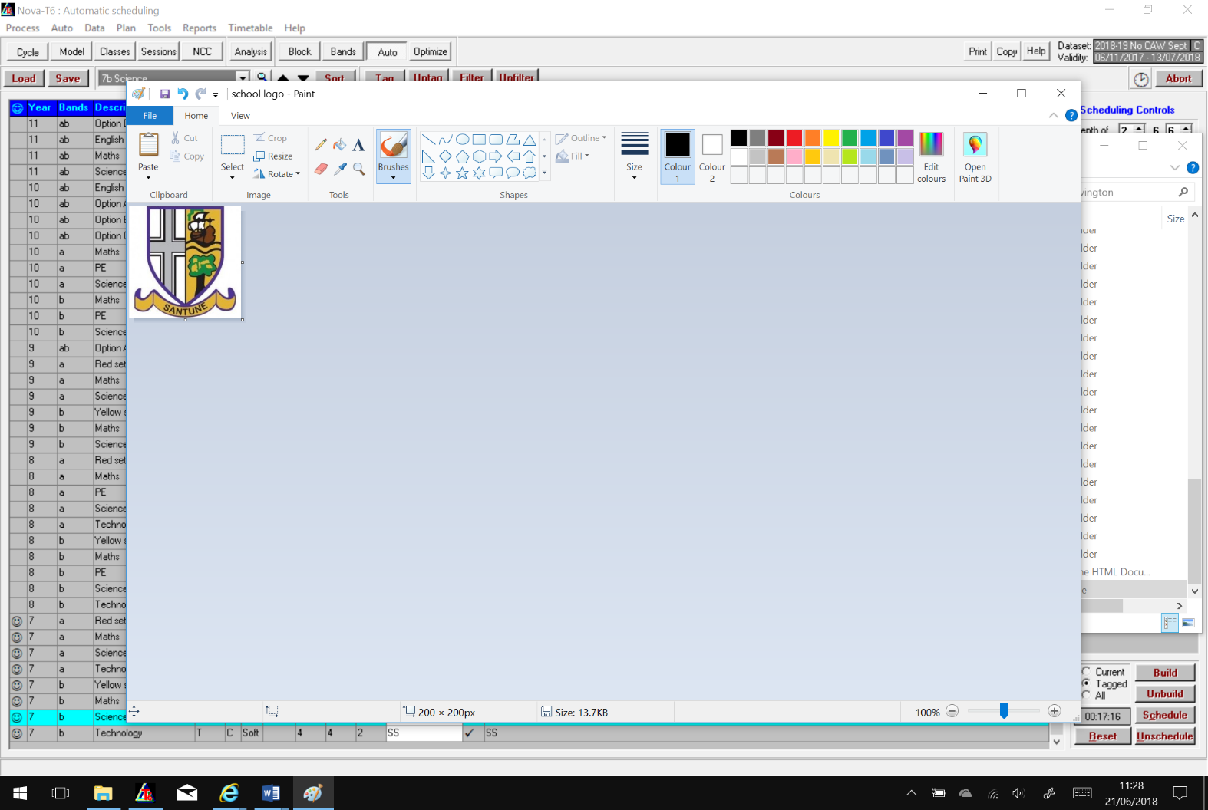**Shavington Academy**

**SEF Departmental Review**

**Department: History Date: 15/5/23**

|  |  |
| --- | --- |
| **Departmental Context**  *(Staffing/experience of team etc)* | 3 full time subject specialists (CL, assistant CL, and a pastoral responsibility) teaching GCSE History, Ancient History and Citizenship. 2 teachers of History on a split timetable, subject specialists but have not taught our curriculum previously, one of these is an RQT. In addition, one experienced subject specialist on maternity leave.  Strong uptake of all 3 options subjects: current Y10: 38 Citizenship, 83 History, 19 AH. |
| **Outcomes**  *(most recent internal data/comparison to external results if possible)* | Summer 2022 GCSE results were outstanding for all 3 subjects – significantly above national averages. This has been consistent for the past five years. e.g. 2022 History: 41% grades 7-9, AH: 30% grades 7-9, Citizenship: 71% grades 7-9.  Internal tracking shows lower progress for current y11 – this is an uncertain prediction based on increased content in the History and AH GCSEs for this year, changing grade boundaries and a desire to not over-inflate pupils’ predictions.  Across all groups, attendance is the most clear indicator of progress made. |
| **Quality of Education**  *(brief overview of learning journey/core knowledge)* | Our lower-school curriculum is designed to fully meet the National Curriculum and to enable pupils to understand their place in the local, national and international context. We also aim to prepare pupils for all three GCSE subjects. We have recently continued developing the level of diversity within our curriculum. We use the Historical Association to support our CPD and subject-specific pedagogy. |
| **Extra curricular offer**  *(outline what is delivered outside of curriculum time/Trips etc)* | History club – lower school  Residential trip – Berlin – GCSE History  Day trip – Cambridge – GCSE Ancient History  Day trip – British Museum and British Library – GCSE Ancient History  Day trip – Parliament – GCSE Citizenship  KS4 – Great Debate club and hosting  KS4 – Debating team competition  Use of PP funding to support inclusion for disadvantaged pupils |
| **Current Actions around key priorities**  *(outline key areas of SIP and impact to date since September)* | Historical Association Quality Mark application is ongoing – a high bar to meet!  Subject-specific support for GCSE teachers – use of exam board materials and meetings.  AH – improve exam technique on Alexander hte Great essays – trip, tutoring and improved resources.  Improved GCSE resources to support knowledge retention and recall for lower-ability pupils.  Lower school vocabulary – displays and resources support consistent approach to tier 2 words.  Teaching and resourcing of Power and the People unit improved in light of exam results review – impact has been seen on mock exams so far, expected to narrow the gap to our other units in summer 2023. |
| **Planned Actions**  *(outline key areas that will continue to be a focus for the remainder of the year)* | Subject-specific support for those new to teaching our curriculum – meetings, resources, models, observations, mentorship etc.  Reading – improving access to materials for pupils, especially challenging exam-specific texts.  Adaptation of lower school curriculum in response to changing timetable for GCSE – less time at GCSE means necessity to prepare pupils more explicitly in Year 9. |