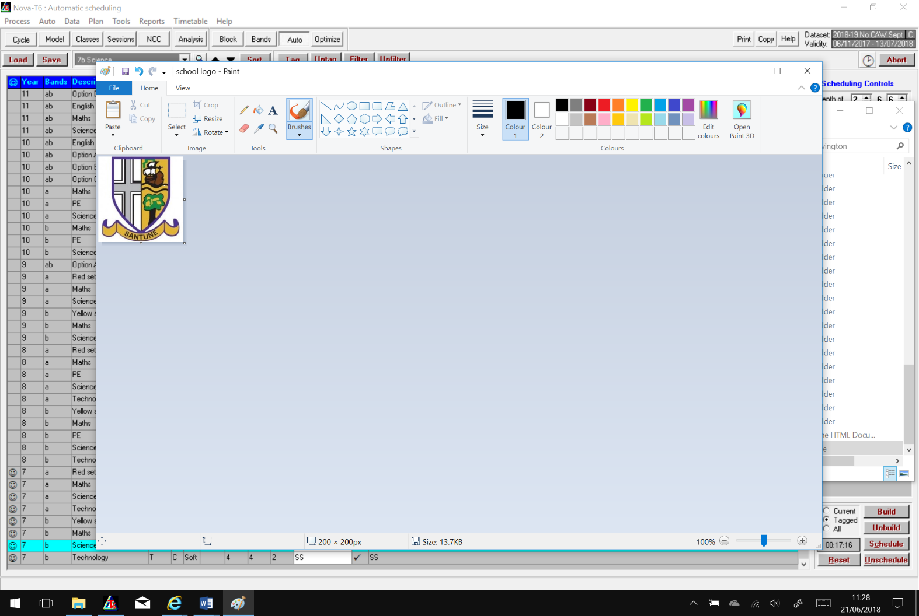**Shavington Academy**

**History Learning Journey**

**Year 8: How do we know that the Industrial Revolution changed lives in Cheshire?**

|  |  |  |  |
| --- | --- | --- | --- |
|  | **Big Questions** | **Core Knowledge** | **Assessment** |
| **1** | **What was the industrial revolution?** | Using 2012 Olympic games opening ceremony video students to identify changes.  Explicit teaching of the words Industrial and Revolution.  Creating links between industrial revolution and topics studied in year 7 – empire and trade. | Questioning around linking phrases together to make links across the curriculum |
| **2** | **What did the industrial revolution look like?** | Use of sketches of countryside/towns to focus on changes between 1750, 1830 and 1890 in terms of:   * Land use * Transport * Power * Jobs   Key changes include: Population growth, especially in towns. Decrease in agricultural jobs. Increased mechanisation. Use of coal, gas and electricity. Canals, trains and trams used for transport. | Written explanation questions about what changes pupils have seen over time |
| **3** | **Why did the population of Britain increase rapidly between 1750 and 1900?** | Focus on grouping causes of the industrial revolution. Pupils to have knowledge on the following causes:   * Diets * Health and hygiene * Education * Jobs and economic causes * Marriage   Use of bespoke causation cards made by Shavington staff. | PEE written explanation of why the population increased |
| **4** | **Why did Mrs Miggins die?** | Poor hygiene led to diseases such as cholera spreading rapidly.  Links between: rapid increase in the urban population, poor sewage systems, cesspits and privies, wells for drinking water. | Questioning throughout lesson about theories  Final written explanation of why Mrs Miggins died |
| **5** | **How do we know about Cholera in Nantwich?** | Causes of disease in towns and cities. Back to back housing, lack of sewerage systems, overpopulation – using sources to identify how the causes from last lesson were evident in Nantwich.  How can different sources help us to learn this?  Sources from Nantwich:  Interviews, maps from 1851 and 1876, records of baptisms and burials, official report on cholera in England 1852. | Questioning around how it is similar/different today  Opportunity to summarise key learning |
| **6** | **How do we know that mines were dangerous?** | How mines changed and developed to meet the demand for coal, and the impact of this (dangers and accidents).  Utility of sources relating to the Trimdon Grange and Gresford Colliery disasters: burial registers, hymn tune, folk music, written account from a survivor published in a local newspaper in 1882, official report into Trimdon Grange disaster. | Self-reflection opportunity at the end of the lesson |
| **7** | **What can we learn from mining sources?**  **(Responsive Assessment)** | Analysis of a report from a local doctor interviewed as part of a parliamentary commission. | Source analysis work sheet – feedback gives opportunity to improve |
| **8** | **Were factories and mills a positive change?** | Teaching of the use of cotton – links to empire and growing cotton elsewhere for it to be processed in Britain. Use of sources to look at positives and negatives of cotton mills.  Including sources relating to Quarry Bank Mill, Styal: photographs, description plus evidence from Parliamentary Commissions and factory inspectors.  Positives include guaranteed work, minimum wage, house provided, local facilities provided, schools and unions  Negatives include dangerous work, accidents, child labour, low wages, long hours, long term injuries | Questioning around positives and negatives that pupils found from the sources |
| **9** | **How much revolution was there in Crewe?** | Focus on Crewe and how it changed once the railway was built during the industrial revolution. Key findings are:   * Before Crewe railway station was built in 1837, there was no town. After the railway station and railway works were built, the town developed very quickly. * The population of Crewe increased from 70 in 1831 to 40,000 in 1871 * The railway company opened a cheese market, a school, churches, a doctor’s surgery and Queen’s Park.   Students have opportunity to use sources from Crewe, including analysing the provenance of sources to determine utility.  Use of: maps, newspaper articles, statistics, *The Imperial Gazetteer 1872*, Crewe Alex FC website, | Explanation about which three sources are best to use to represent the topic  Must have consideration of knowledge and provenance of sources |
| **10** | **How much can we trust one source?** | Source analysis of Crewe sources using knowledge from prior lesson. Students attempt and teacher feedback given. | Questioning whilst completing source analysis |
| **11** | **How did the people of Shavington change?** | Pupils to have the opportunity to look at the census of Shavington over time and key findings are below:  Shavington developed after Crewe. Before the industrial revolution, most men in Shavington were agricultural labourers and most women did not have a specific job. From the 1850s, many more people moved to live in Shavington and work in Crewe railway works. Some did other industrial jobs. More children began to go to school. The Vine Inn opened along with many churches and a school. | Written explanation questions |
| **12** | **How useful are newspapers? (Progressive Assessment)** | Assessment of source skills and knowledge acquired about the industrial revolution with a focus on Crewe. | Teacher feedback given |
| **13** | **How did the industrial revolution affect the franchise?** | Explicit teaching of keyword franchise, useful for KS4 History and Citizenship curriculum. Teaching of the chartists and their demands. Key individuals of William Cuffy and Thomas Dunning and how the Chartists are commemorated. | Explanation task of how the Chartists should be commemorated |