History: Local history study – Handsworth Road

Year 4

/10

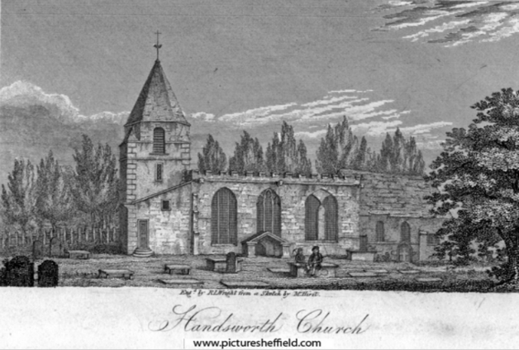

**Name: …………………………**

1. When was St Mary’s church founded?

……………………………………………………………………………………..

1. Who is said to have founded St Mary’s church?

……………………………………………………………………………………..

1. When did Handsworth become part of Sheffield?

……………………………………………………………………………………..

1. What type of occupation was Handsworth Road known for?

……………………………………………………………………………………..

1. Where was the first known mention of Handsworth?

……………………………………………………………………………………..

1. What is special about the Chantry Inn?

……………………………………………………………………………………..

1. How many listed buildings are there on Handsworth Road?

……………………………………………………………………………………..

1. Name one.

……………………………………………………………………………………..

1. What is a trade directory?

……………………………………………………………………………………..

1. What is significant about Handsworth Road?

……………………………………………………………………………………..