Three Immersive Exercises: The Nervous State
The history of appeasement, the successes and failures of peace initiatives in international relations, and the social history of World War II are popular topics in high schools, and at GCSE and A-level.
They are, however, taught mainly from the perspective of history from above, with less regard for the psychological, personal, and popular experiences of living in times of acute international crisis, and the ways in which we all inevitably internalise the failures of peace.
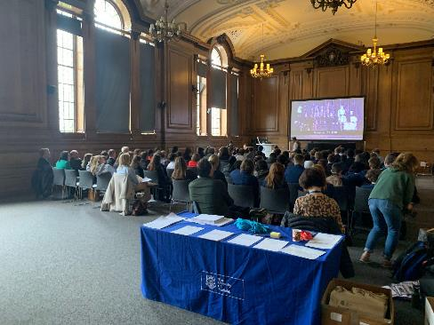
In April 2023, the University of Sheffield invited Key Stage 4 and 5 historians and their teachers to an afternoon of immersive learning – featuring a live performance of The Nervous State – a new play written by renowned playwright Nicola Baldwin, in collaboration with Professor Gottlieb – which dramatises F.L. Lucas’s non-fiction account of the year leading up to the outbreak of World War II, Journal Under the Terror, 1938 (1939).

For more information on the event: https://player.sheffield.ac.uk/events/history-from-within
For more information on the play, The Nervous State: https://player.sheffield.ac.uk/events/nervous-state-collaboration-performances-and-impact
Staged reading of the play:
https://www.youtube.com/watch?v=gfUbzX0jL2U&t=106s
For more information on the collaborative between Professor Gottlieb and Nicola Baldwin: https://historymatters.sites.sheffield.ac.uk/blog-archive/2023/nervous-state
The performance led into Q&A with Nicola Baldwin and the actors, then on to three immersive workshop sessions: 1) Journal Writing; 2) Sources for a History from Below and a History from Within the Munich Crisis; and 3) A Scene Study from “The Nervous State”.
The resources used in these workshops were aimed at encouraging students to engage with new perspectives and approaches, looking at history from the bottom up - reflecting on how we think about times of crisis. These can be found below.

- Journal Writing
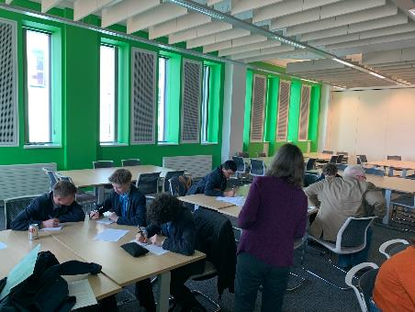
F.L. (Peter) Lucas undertook to keep a journal for one calendar year, starting on 31 December 1937. His entry for the first day explains his motivations:
[T]his journal, if it can be kept alive, is not merely for my own private remembrance of the past. I dare to hope that parts of it may amuse the future also--supposing there is any future—supposing that future feels any curiosity about to-day. This is a message in a bottle, thrown overboard at a venture from this vast ship of ours that drifts… It is an attempt to give one answer, however inadequate, however fragmentary, to the question that will surely be asked one day by some of the unborn—with the bewilderment, one hopes, of a happier age: ‘What can it have felt like to live in that strange, tormented and demented world?
Lucas was writing his journal as a chronicle of his age, and as a document that would be useful to future historians. As a scholar himself, Lucas understood very well that historians learn a great deal from subjective sources. These kinds of sources give insight into the personal against the backdrop of major historical events. They can tell us about how ordinary people experienced major events.
The Exercise (20 minutes to write):
Start your own journal, and write your own “message in a bottle” that documents “what it felt like to live” in 2023. Remember that the Collins’ Dictionary word of the year for 2022 was PERMACRISIS. Your diary could well be titled Journal under the Permacrisis.
You may wish to chronicle what you did today, your journey to the University of Sheffield, the sights and sounds, signs of the times along the way, an interesting conversations you had, and/or your response to watching the play The Nervous State. Think about what is in the news right now, and how current events intrude (or do not) into your life and thoughts—cost-of-living crisis, inflation, migrant crisis, political instability, the war in Ukraine, natural disasters, the climate crisis, the pandemic etc.
Peer Review (10 minutes to discuss)
In pairs, discuss your experience of writing your own journal entry.
- What did you find easy or difficult about writing about your own moment in history?
- What information and details did you include in your message in a bottle?
- What did you learn about journals as a historical source by writing your own journal entry?
- Compare and contrast your journal entries in terms of style, approach and content. What does the way you went about this exercise reveal about you?
Reflection: working with sources (20 minutes):
Back in your group-- seminar style-- discuss approaches to source criticism. What should history students be looking for when presented with a source like Lucas’s journal entry from 31 December 1937, or with their own diary entry?
Provenance: Where is the source from? Who is it written by? What is the point of view of the author? What are the intentions and who are the intended audiences for the source? Is it published or unpublished, and why does that matter? Who has access to it?
Nature: What kind of source is it? What is the nature of the source? What are the differences, for example, between a newspaper article, an official government document, and a private journal entry about the same event?
Context: What else is happening at the time in the life of the author, in their family and community, in their town or city, in the country they live in, and in the world at large?
Significance: What does the source tell the historian? What insights will the historian gain from the source? What may remain obscured?

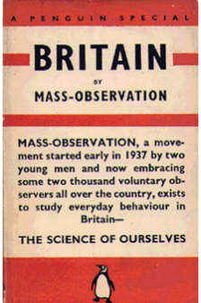
2. Sources for a history from below and a history from within of the Munich Crisis
Traditionally, historians have studied the Munich Crisis from the point of view of high politics, diplomacy and international relations. The focus is on the key players Hitler, Chamberlain, Mussolini and Daladier who signed the Four Powers Agreement in Munich on 30 September 1938, an agreement that sealed the fate of Czechoslovakia. In the short term, many people felt an overwhelming sense of relief that war was averted, while others were more critical and felt shame at the way Czechoslovakia was sacrificed.
It is important to recognize that the Munich Crisis had a deep impact on ordinary people, across class, regional, gender and generational divides. Almost everyone was on edge and in suspense, reading each new edition of the newspapers and listening to the wireless (the radio) to find out if it would be peace or war. For what kind of war were the people bracing? This was a different kind of war than that of 1914-18, a war from the air and in which the bombers would make no distinction between soldiers and civilians. 25 September was dubbed ‘Gasmask Sunday’ as gas masks were distributed to the British civilian population, in anticipation of gas attacks. It is for these reasons that we need to think about the Munich Crisis not only as a climax of the diplomatic crises of the 1930s, but as a people’s crisis too. It was the first battle in what many people were describing at the time as a ‘war of nerves.’
In this session, juxtapose three sources that offer different vantage points on the same event. Compare and contrast them, and consider the following:
Provenance: Where is the source from? Who is it written by? What is the point of view of the author? What are the intentions and who are the intended audiences for the source? Is it published or unpublished, and why does that matter? Who has access to it?
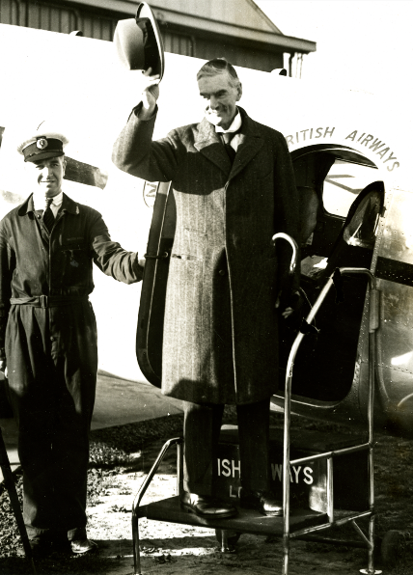
Nature: What kind of source is it? What is the nature of the source?
Context: What else is happening at the time in the life of the author, in their family and community, in their town or city, in the country they live in, and in the world at large?
Significance: What does the source tell the historian? What insights will the historian gain from the source? What may remain obscured?

Image: Neville Chamberlain acknowledging the crowds upon his returning to Downing Street following the Munich Agreement, 1938, World Wide Photos. Cadbury Research Library, The University of Birmingham. 17/1/19/6 NB.

1.
What follows is from the archives of Mass-Observation, a volunteer-led social research organisation established in 1937 to survey the attitudes, ideas and habits of the British population, and conduct an “anthropology of ourselves”. Mass Observers agreed to both record what they heard in public and private settings, and to write down their own thoughts about the Munich Crisis as events unfolded. Their responses were then sent to Mass-Observation, and they were among the sources analysed by Tom Harrisson and Charles Madge in their Penguin Special Britain by Mass-Observation (published in January 1939). Here we have Mrs I Blackwell giving her spontaneous response to events on 28 September.
Blackwell, I 3568, “Comments on the Crisis”, 28 September 1938, M-OA: Directive Replies 1938, Box 11 of 13, Munich Crisis, Sept.-Oct.—Women
I am one of these people who always follow the international news. I have been very worried over it and have been expecting war for a long time… Last week I felt ill with worry and not much better when Chamberlain came to his agreement with Hitler, for I felt if Hitler was allowed to get strong enough to dominate Europe we should have a war sooner or later and I would rather have it now, before he is too strong. Once war seemed a certainty, I lost my worry and began to feel quite an exhilaration in all the bustle and hurry, the anti-aircraft guns, searchlights, trenches, gas masks, queues…The atmosphere was exciting and chilling, so when the news came through about the Four Power Conference which seemed to out of the war I felt almost flat… Some think we are willing to fight for democracy against dictatorship and others for fear of German domination of Europe. Few seem to consider Czechoslovakia the real cause.
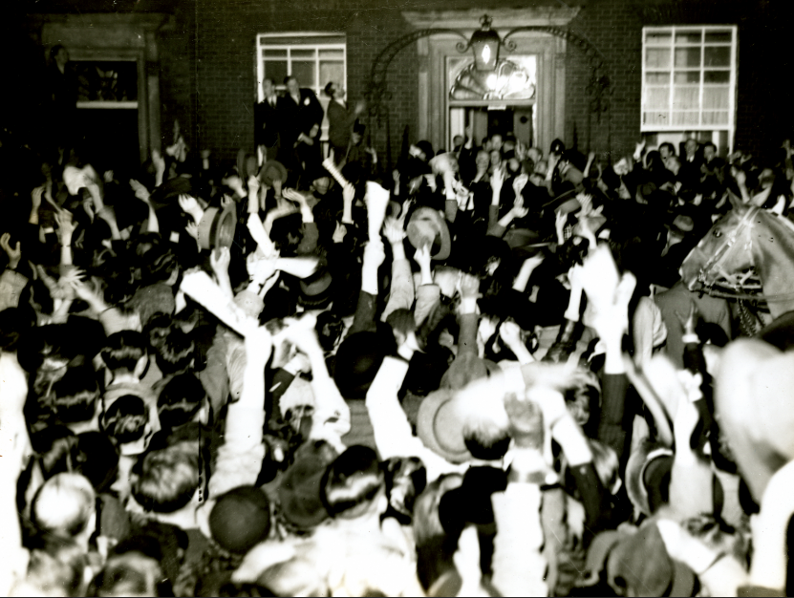
Image: Crowds cheering for Neville Chamberlain upon his return to 10 Downing Street, London, following the Munich Agreement, 1938, World Wide Photos. Cadbury Research Library, The University of Birmingham. 17/1/19/118 NB.

2.
From F.L. Lucas, Journal Under the Terror, 1938 (London: Cassell, 1939), this entry is from 30 September, 1938, and an immediate response to the signing of the Munich Agreement. Lucas makes two entries, first in the earlier part of the day and then later that evening.
Sept 30th Hitler, Mussolini, Chamberlain, Daladier have met at Munich.
The danger is probably over till the blackmailers’ next demand. We shall have sold the Czechs for six months’ grace, and a disgrace that will last as long as history.
But the democracies are scared so white that to many it will easily seem a diplomatic triumph.
Meanwhile the German press has omitted from its reports of Chamberlain’s speech his remark that war is a “nightmare” to him. Hopeful people to make peace with, these men who will not allow war even to be spoken against; not even by a foreign statesman!
Later. Cambridge. The sale of European decency is completed. The occupation of Czechoslovakia begins tomorrow and is to be completed by October 10th. The Czech appeal to Roosevelt is ignored. In front of the radio one felt physically sick.
“Sleep quietly in your beds,” says the Prime Minister to the hysterical mob of London, cheering madly because cowardice has saved their own skins, forgetful of English dignity, forgetful of the agony of Prague. “It is peace for our time.” My God!
And he waves a piece of paper with Herr Hitler’s signature – the signature of that hand which has sent to death, or to torture worse than death, so many innocent men and women, so many comrades of his own; the hand that has written one of the vilest and cruellest books in history.
Has the War bled England white-livered?
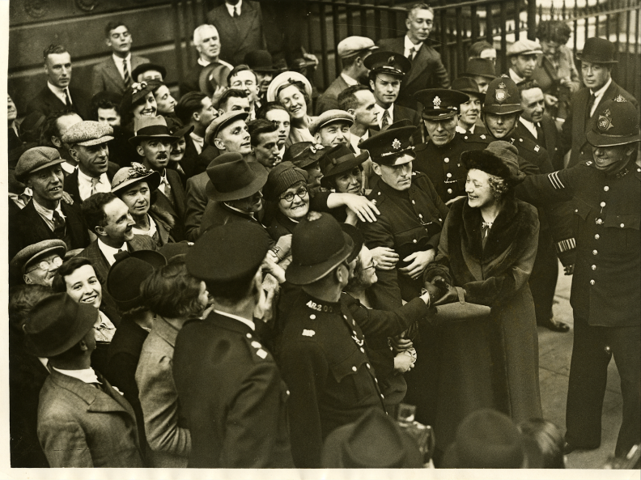
Image: Neville Chamberlain’s wife, Annie Chamberlain, greeting the crowds in London following the signing of the Munich Agreement, 1938. She stayed in London while he was at the Four Powers Conference in Munich, and she always attracted an enthusiastic crowd on her outings from Downing Street. London News Agency Photos Ltd. Cadbury Research Library, The University of Birmingham. 17/1/19/95 NB.

3.
British Prime Minister Neville Chamberlain never kept a diary, but he was in regular correspondence with two of his sisters, Hilda and Ida, and he placed great store in their views and their approval. Other leading politicians in the controversies over the policy of appeasement either/or kept diaries or published memoirs, securing for themselves a legacy and protecting their reputations. In this diary letter written by Neville to his sister Hilda on 2 October 1938, he describes the dramatic events in Parliament when he received the invitation to Munich, another chance to broker a peace after the failure of his two visits to Hitler earlier in September.
For me, I confess that it seemed only too possible that all the prayers of all the peoples of the world including Germany herself might break against the fanatical obstinacy of one man. I daresay Annie [Chamberlain’s wife] has told you or will tell you of the birth of the last desperate snatch at the last tuft of grass on the very verge of the precipice. That the news of the deliverance should come to me in the very act of closing my speech in the House as a piece of drama that no work of fiction ever surpassed. The events of the next 48 hours entail terrific physical and mental exertions…Even the descriptions of the papers gives no idea of the scene in the streets as I drove from Heston [aerodrome] to the Palace. They were lines from one end to the other with people of every class, shouting themselves hoarse, leaping on the running board, banging on the windows & thrusting their hands into the car to be shaken. The scenes culminated in Downing Street when I spoke to the multitudes below from the same window I believe as that from which Dizzy [Benjamin Disraeli] announced peace with honour 60 years ago.

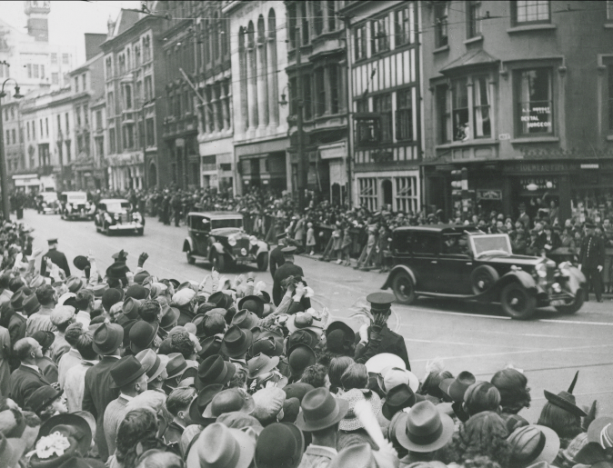
Image: Neville Chamberlain and his motorcade en route through London after arriving at Heston Airport following the signing of the Munich Agreement, 1938. Cadbury Research Library, The University of Birmingham. 17/1/19/115 NB.

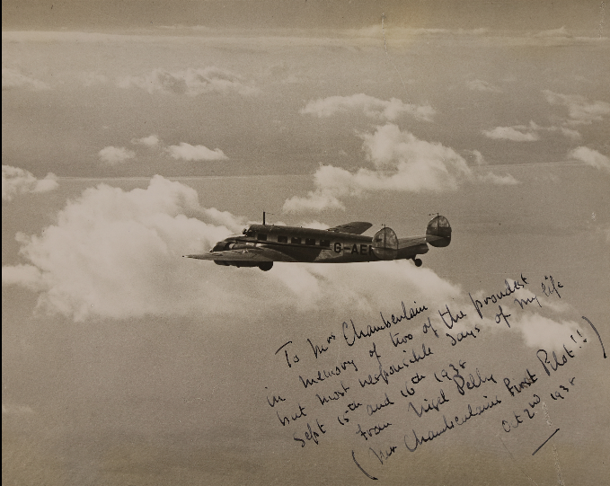
Image: Photograph of the plane that took Neville Chamberlain to Munich in advance of the Munich Agreement, signed by the Pilot and gifted to Chamberlain, 2 October 1938, The Times, 1938. Cadbury Research Library, The University of Birmingham. 17/1/19/11.

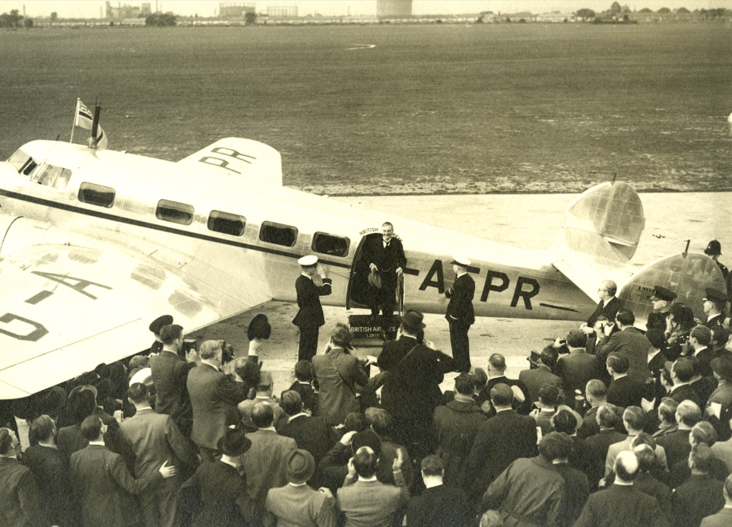

Image: Neville Chamberlain exiting the plane at Heston Airport to meet the crowds following the signing of the Munich Agreement, 1938. Cadbury Research Library, The University of Birmingham. 17/1/19/20.

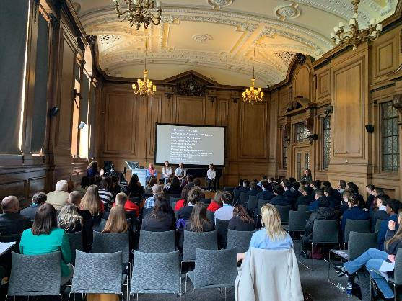
3. Scene Study from Nicola Baldwin’s “The Nervous State”, a dramatization of F.L. Lucas’s Journal Under the Terror, 1938 (1939)
There are many ways to connect with the past, and to relate to the way people felt living in times of crisis. Dramatic re-enactment allows us to put ourselves in the shoes of historical figures through characterisation, and staging offers an opportunity to compare historical sources with each other.
The Nervous State interweaves different historical sources. The words of ‘PETER’ are taken from the Journal of F L Lucas, which itself includes personal observation and reflection, newspaper articles and private correspondence. The words of ‘PRUDEY’ are fictionalised from things said about her in secondary sources, such as the diaries of Joan Wyndham, and anecdotes passed down from people who met her (no direct sources for Prudey exist). The words of ‘GUDRUN’ come from Newspaper reports which appear in Peter’s Journal, and dialogue from his play, The Lovers of Gudrun, which was his interpretation of the only female subject of the Icelandic Sagas.
In staging historical drama, the playwright, director and actors ask themselves similar questions to the historian. Who is speaking these words? What is their aim? Who is their audience? What is said about different characters by whom, and why? But they also ask questions which are specific to drama, such as whose voices are privileged at any moment and how may this change during a scene?
Dramatic storytelling is driven by change but the nature of that change is created in each performance and reception by the audience. What is the aim of the playwright through these words and characters? How does the staging work to reinforce or offset these aims? How does the audience receive the information from text (spoken words) and staging (action and stage blocking) and actors’ performance?
In this immersive exercise, you will stage a short scene from “The Nervous State”. There are three roles: Peter, Prudence and Gundrun/the narrator. There is no expectation that you will memorise the lines but try to read with dramatic effect.
- Think about how the characters might have spoken, expressed or hidden their feelings, when they may be serious, earnest, sarcastic, cynical, light-hearted and/or down.
- Think about how characters might be positioned in the scene. What happens if one character is given prominence above another? What happens when characters face each other, or turn away? What happens if you experiment with the stage ‘picture’, for example to have one character approach the audience, or walk away while another character speaks?
- How do you create sympathy for characters in drama? How can you imply hidden feelings?
- What insights into the past-- into events as well as emotions—does participating in historical re-enactment provide?
- Peter Lucas said very little about his wife Prudence in the Journal, and therefore her words are imagined, based on research on her in other sources. Why is it important to give unrecorded characters such as Prudence their voice back?
- Can you create a fourth character, with or without words, from what is described in the scene? Who might this be, and what is their role in the stage action?
- If you gave the play a proper production, with memorised dialogue and lighting, how might you approach your staging? How would it look? What would you do to interpret the story?

Choose one scene from the play “The Nervous State”
Either:
Option 1 - July 1938
Peter and Prudey stand, enthusiastic

PRUDEY Up to Turtagrø (Turtagr-urr) in Jotunheim (yō-​tᵊn-​ˌhā-​m). Heavy snow.

PETER At the hotel, gazing unwarily at paintings for sale at the door, we were pounced on by the lurking artist – a German Dada painter whose works had incurred the honour of being exhibited in the Reich as specimens of “degenerate Art”.

PRUDEY As Dada fills my husband with only less loathing than Nazi policy, a good deal of dissimulation became necessary on his behalf…

GUDRUN July 7th

PETER One of the best, though most laborious, of days. Lost for hours, through endless scrub to the Tussvann…. Over its crowning edge, an easy plunge down steep, deep snow – hundreds of feet in a few minutes. Under the fantastic crags “the Bride’s Procession”….

PRUDEY Further on… a curiously different bridal-procession on a lonely road –
a disconsolate girl in bridal dress, a younger girl, and two young men, all downcast.
An enforced marriage? Or had the bridegroom never come?
(she speaks directly to us)
Further still, the gate of the little church, empty now, still decorated for the wedding with fir-branches. Already they were beginning to droop...

PETER Train to Esbjerg (Esb-yerg); English faces. Before us loom the grey distances of the North Sea. It is depressing that England on approach should suggest the back-yard of a factory… One comes back to The Times Newspaper...

GUDRUN “All talk of compromise in Spain plays into the hands of the war-mongers…”

PETER Suicides in Vienna are now 800 a month; the Chief Rabbi, has been forced to stand outside a Jewish shop in that civilised city, wearing a placard “Boycott the Jews”.
(Prudey moves a little way off)
The Bishop of Gloucester has been adorning The Times with justification of the persecution of Pastor Niemöller. The fellow dared to mention politics in his sermons –

GUDRON /“Even in this country we do not like political sermon”

PETER Though of course, we simply adore letters from Bishops in The Times.
When my friends talk of the danger of Fascism in England… sometimes I wonder.

Or:

Option 2 – October 1938

GUDRUN A Czech broadcast today, in English, ending with these words: “We bequeath our sorrows to the French and English peoples.”

PETER Only ten months since I went to a meeting of intellectuals, called by Miss Eleanor Rathbone in Gower Street, to see if something could be done to save Czechoslovakia.
Alas, some of us were pacifists, and some of us were this, and some of us were that, and Miss Rathbone herself was a better man than half of us. We could not agree. Now the poor Czechs have gone to their fate.

PRUDEY There’s a nice girl I see every day on the road. I think I’m a bit gone on her. Waft of her perfume, and there she is, smiling as she swishes past… Makes me go a bit Beethoven’s fifth.
This morning…. I ran after her. The poor thing bolted like a colt as I gave chase, cornering her behind the Lyons tea shop…
Excuse me, but you look like a Sleeping Madonna.
I hear myself say… your hair is so pretty… Apart from the Kirby grips and glasses. Did I say that out loud?

GUDRUN Oct 8th The International Commission for the Czech frontiers

PETER / - yielding point after point to the German demands….
Mr Chamberlain fishes. Pontius Pilate can wash his hands in the nearest trout-stream.
GUDRUN 800,000 Czechs now handed to Germany

PRUDEY A terrible flash of light and a sound like the crack of doom.
I wake up on the floor, and the house is moving. Am I dreaming?
Is the house filled with smoke… or night-time?
For the briefest moment… the whispering of bodies, covered in dust, the corpses all excited talking with each other. Like a party of those who do not realise they are dead.
If… If the bomb did fall…
Two treasures, I’d save (2 fingers); my Helena Rubenstein Apple Blossom Skin Fragrance; my precious novel. Save my skin (touches her arm) and… (her forehead)…. All my thoughts.
I cannot bear to think of my words being blown away….

GUDRUN Oct 11th Cambridge. PETER Michaelmas term.

PRUDEY Michaelmas daisies. Yellowing hags of trees; grass green as youth.

PETER The world is going to need all its courage. Luckily one can always die….
(Prudey covers her ears, recoils)
I often think it is not the least of the virtues of a car that the fumes of its exhaust will convey one so smoothly down to the shores of Styx. None knows in these days when he may not need to be carried out of the world, as well as through it.
Digging in the garden. Admirable for the spirits; I could not help wondering what it would feel like to be digging one’s own grave before a firing party.

GUDRUN Oct 17th A letter from Czechoslovakia. “i can’t describe to you the anguish of a life-long admirer of English civilisation when the news of the betrayal of democracy arrived. And now it seems we and our fate would soon be forgotten but for honourable men like yourself. I love Cambridge and your letter reminded me of the happy time when I used to lecture on modern drama for Stuart House… The other bank of the Danube has just been occupied by Nazi forces and we can see the Swastika flags from our side. The salvation of Europe seemed so near at hand… only firmness was need.

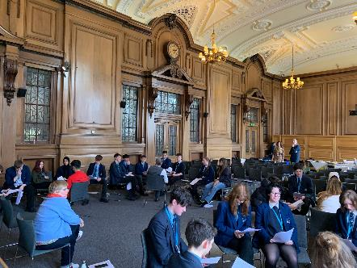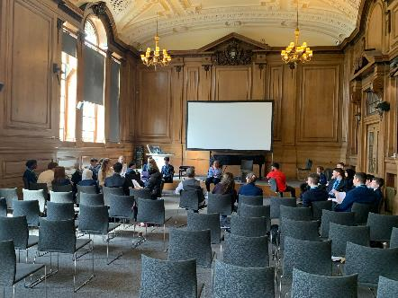

Scene Study Immersive Exercise led by playwright and director Nichola Baldwin, 19 April, 2023, University of Sheffield

F.L. Lucas, Journal Under the Terror, 1938 (London: Cassell, 1939), p.12.
Permacrisis, in British English, (ˈpɜːməˌkraɪsɪs IPA Pronunciation Guide), NOUN. Definition: an extended period of instability and insecurity, esp one resulting from a series of catastrophic events.

