The Harrying of the North
The main text is a History Today article by James Aithcheson (2016)
www.historytoday.com/history-matters/harrying-north
Victory at the Battle of Hastings did not guarantee William control of England. The rebellious North had to be brought into line – which it was, ruthlessly, in the winter of 1069.

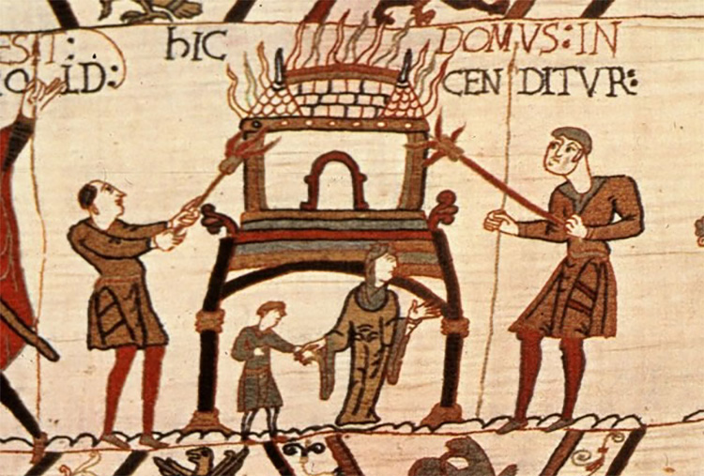
TASK: Read the information and answer the questions in full sentences. Use at least one quotation from the accompanying source material to support your answers.
Source 1: Normans burning Anglo-Saxon buildings, in a scene from the Bayeux Tapestry. This image appeared with the original article, but is somewhat misleading. In the tapestry, this scene is not referring to the Harrying of the North, but rather the days prior to the Battle of Hastings. It shows Normans burning an Anglo-Saxon house and terrorizing the local population – most likely to force Harold to come to fight William quickly.
Image: www.historytoday.com/history-matters/harrying-north

‘The Battle of Hastings is the most famous event of the Norman Conquest, but it was only the opening engagement in the invaders’ consolidation of power in England. For several years afterwards, the country was riven by internal conflict as the Normans fought to extend their rule, climaxing in a notorious campaign known today as the “Harrying of the North”.
The Harrying, which took place over the winter of 1069–70, saw William’s knights lay waste to Yorkshire and neighbouring shires. Entire villages were razed and their inhabitants killed, livestock slaughtered and stores of food destroyed. This scorched-earth operation is one of the defining episodes of the Conquest, not just from a military-political perspective but also in terms of how it has shaped modern perceptions of the Normans as a tyrannical and merciless warrior class. But why were such brutal measures considered necessary and why was the north in particular targeted?’
These activities are described in several sources, e.g. The Anglo-Saxon Chronicle (ASC) (Worcester manuscript) says: ‘Then when the king learnt this, he went northward with all of his army which he could gather, and wholly ravaged and laid waste the shire.’

1. Why is the use of the image shown from the Bayeux Tapestry in this article misleading (use the information next to the image!)?
2. What sort of things did the Norman army do as part of the ‘Harrying of the North’?
‘By the winter of 1069, the Norman war machine had been active in the field for more than three years. Throughout 1067 and 1068 there had been a succession of localised revolts and incursions by foreign foes in various corners of the country – Devon, Kent, Herefordshire and the midland earldom of Mercia – although each of these was swiftly put down. Castles were established, including in the major towns of Warwick, Nottingham, York, Lincoln, Huntingdon and Cambridge, in an effort to quell the disturbances and impose control. Nevertheless, it is important to recognise that, even by the beginning of 1069, William was still not master of the entire kingdom. His authority extended no further north than York and it was in the region beyond that the greatest threat to his rule lay.
Some of the key rebellions actually came from the Godwin family: The ASC (Worcester) tells us: ‘And in the middle of this [1068] Harold’s sons came by surprise from Ireland into the mouth of the Avon with a raiding ship-army, and straightaway raided across all that region; then went to Bristol and wanted to break down the town.’

William’s early attempts to bring the northerners under his heel had involved appointing native English earls to govern them: first Copsig and then Gospatric. Both appointments had been dismal failures: the former was assassinated by a rival in 1067; the latter defected in 1068 to the midland rebels. Finally, in January 1069, William sent one of his own men, Robert Cumin, at the head of an army to conquer the region by force, only for them to be ambushed and slaughtered at Durham.
Worse was to come. That summer the Normans found themselves at the centre of a perfect storm, as their enemies all began marching at once. Foremost among them was a coalition of Northumbrian noblemen, including Gospatric but led by Edgar Ætheling, then around 17 years old and making a fresh bid for the crown, having already been briefly acclaimed king in London following Harold’s death in 1066.
Sources such as Geffrei Gaimar and here, The ASC (Worcester), tell us: ‘1068 Here in this year King William gave Earl Robert the earldom over Northumberland, but [1069] the local men surprised him inside the stronghold at Durham, and killed him and 900 men with him. And immediately after that the aetheling Edgar came to York with all the Northumbrians and the men of the stronghold…
Soon thereafter three sons of King Swein with 240 ships came from Denmark into the Humber. And there came against them Prince Edgar, and Earl Waltheof, and Maerleswein, and Earl Gospatric with the Northumbrians, and all the people of the land, riding and marching with an enormous raiding army, greatly rejoicing; and thus all resolutely went to York and broke down and demolished the castle, and won countless treasures in there, and there killed many hundreds of French men.’

The Northumbrian threat was compounded in August when a Danish invasion fleet numbering some 240 or 300 ships – depending on which source we believe – arrived in the Humber. The two forces swiftly formed an alliance and together attacked York. Meanwhile there was further trouble on the Welsh border, where a rebellious thegn named Eadric had joined forces with the Welsh kings and the men of Chester. In the south-west, the men of Devon and Cornwall were in revolt.
It is unlikely that these risings were co-ordinated; the impression given by the sources is that their timing was coincidental. But the crisis nonetheless tested the Normans to the limit and marked a crucial turning point in the Conquest.’
3. What threats did Williams face to his rule in 1068 and 1069?
E.g. ASC (Worcester): ‘And the fleet lay all winter in the Humber, where the king could not come at them. And the king was in York on Midwinter’s Day, and in the land thus all the winter.’

‘Leaving the problem of the south-western insurrection to his deputies, William first confronted the Welsh and their allies, crushing them at Stafford, before marching north. He eventually reached York a little before Christmas, only to find that, on hearing of his approach, the Northumbrians and their Danish allies had strategically withdrawn: the former to their hiding-places in the hills and woods; the latter to their ships in the Humber.
Frustrated by his inability to meet his principal enemies in battle, William was forced to adopt a new strategy. He secretly approached the Danes, promising them a vast amount of silver and gold if they would leave England in the spring, to which they readily agreed. That accomplished, William then turned his attention to the recalcitrant Northumbrians, who had proven a perennial thorn in his side. Shortly after Christmas in 1069 he divided his army into raiding-parties, which he dispatched to carry out the Harrying.
Several sources give accounts of William’s actions in the North, e.g.
Geffrei Gaimar: ‘None, however, was to enjoy his share of the loot, because king William arrived on the scene, took the town, and killed all of the Danes and Norsemen. He then continued laying waste everything from there right up to the River Tyne.’
The ASC (Worcester): ‘Then when the king learnt this, he went northward with all of his army which he could gather, and wholly ravaged and laid waste the shire.’
Orderic Vitalis: ‘In his anger, he commanded that all crops and herds, chattels and food of every kind should be brought together and burned to ashes with consuming fire, so that the whole region north of the Humber might be stripped of all means of sustenance. As a consequence, so serious a scarcity was felt in England, and so terrible a famine fell upon the humble and defenceless people, that more than 100,000 Christian folk of both sexes, young and old alike, perished of hunger.’

The object of the campaign was two-fold. First, William sought to flush out and eliminate the Northumbrian rebels. More importantly, by destroying the region’s resources so comprehensively, he sought to put an end to the cycle of rebellions by ensuring that any future insurgents would lack the means to support themselves. The campaign was as efficient as it was effective. William’s armies spread out over more than one hundred miles of territory, as far north as the River Tyne. The 12th-century chronicler John of Worcester writes that food was so scarce in the aftermath that people were reduced to eating not just horses, dogs and cats but also human flesh.
Another historian, Orderic Vitalis – a contemporary of John’s – claims that as many as 100,000 people died as a result of famine in the following months. While we are rightly suspicious of such a round figure, a death toll somewhere in the tens of thousands is not hard to believe: this at a time when the total population of England was probably little more than two million.’
4. How did William deal with the Viking threat (what actions did he take)?
5. How did William deal with the threat from the Northumbrian rebels (what actions did he take)?
‘The affected region took a long time to recover. Symeon of Durham writes that no village remained inhabited between York and Durham and that the countryside remained empty and uncultivated for nine years. Even by 1086, when Domesday was compiled, one third of the available land in Yorkshire was still recorded as vasta (“waste”).
In the course of just a few weeks William had not only clearly demonstrated the punishment that awaited those who rose against him, but he had also snuffed out what lingering hopes the rebels might have had of driving out the invaders. There were further risings in the years to come, but William never again faced a crisis of the same magnitude as he had in 1069. What Hastings had heralded, the Harrying confirmed. The Normans were here to stay.
6. Read the final paragraph. What does the article suggest that William achieved through his actions in the North?

