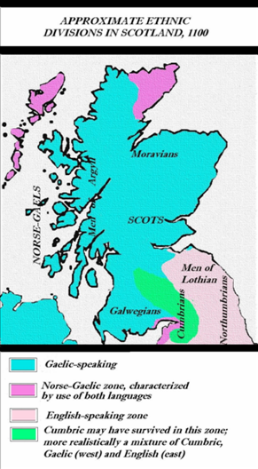**When did the Normans complete their conquest?**

**SCOTLAND**

**Background**

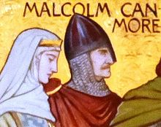In the 1060s, Scotland was a totally separate kingdom to England, with its own royal family and court. At the time of the Battle of Hastings in 1066, the Scottish king was Malcolm III, who had been on the throne since 1058. In the aftermath of the events of 1066, after William had been crowned king, some Anglo-Saxon noblemen sought refuge at the court of Malcolm III in Scotland, and hoped to use it as a base from which to resist the Norman Conquest. The most significant of these were Edgar the Aetheling and his mother and two sisters, who arrived at Malcolm III’s Scottish court for the first time in around 1068.

**Marriage**

After their arrival at the Scottish court, Malcolm III married Edgar the Aetheling’s sister, Margaret. Margaret was known for her piety and virtue, and the marriage created an alliance between the Scottish and old Anglo-Saxon royal families. It is possible that Malcolm also believed that the match might strengthen his plans for expanding Scotland’s southern border into English territory. In 1071, Malcolm invaded the Cumberland, harrying towns and villages and taking some English people back to Scotland as slaves.

**William strikes – the Treaty of Abernethy**

Malcolm’s link to the house of Wessex, along with his incursions into English territory, marked him out as an obvious threat to William. In 1072, King William invaded Scotland by land and sea. However, no major battle occurred, and instead King Malcolm submitted to William’s authority by agreeing to the Treaty of Abernethy. The Scottish king promised to be loyal to William and to expel some Anglo-Saxons, including Edgar the Aetheling, from his court. He also had to give one of his sons, Duncan, to William as a hostage. In return for his loyalty, Malcolm was given some lands in Cumbria in the north of England.

**An uneasy peace**

Despite his promises, Malcolm began raiding on the English border again in 1079, and these raids continued intermittently for some years, with Malcolm succeeding in pushing the Scottish border further south. William died in 1087, and his son William Rufus (II) took over as king of England. William II and Malcolm made peace in 1091, but by 1092 William II was building castles along the Scottish border, and tension once more peaked. In November 1093, Malcolm III launched a raid on the English border. In the battle that followed, Malcolm was killed and his Scottish army were forced to hastily retreat.

*Images: Scotland map,* [*https://commons.wikimedia.org/wiki/Atlas_of_Scotland#/media/File:SCOTLANG1100.PNG*](https://commons.wikimedia.org/wiki/Atlas_of_Scotland#/media/File:SCOTLANG1100.PNG)*; Malcolm and Margaret,* [*https://commons.wikimedia.org/wiki/File:Margaret_and_Malcolm_Canmore_(Wm_Hole).JPG*](https://commons.wikimedia.org/wiki/File:Margaret_and_Malcolm_Canmore_(Wm_Hole).JPG)*; Malcolm’s cross in Alnwick, Northumberland (monument erected in 1774 near the place of his death, replacing an earlier medieval monument),* [*https://commons.wikimedia.org/wiki/File:Malcolm%27s_Cross_-_geograph.org.uk_-_1533754.jpg*](https://commons.wikimedia.org/wiki/File:Malcolm%27s_Cross_-_geograph.org.uk_-_1533754.jpg)*; ruins of Malcolm III’s tower, Dunfermline, https://commons.wikimedia.org/wiki/File:Ruins_of_Malcolm%27s_Tower,_Dunfermline.jpg*

