When did the Normans complete their conquest?
TAKING CONTROL: Castles, cathedrals and Domesday
1.CASTLES
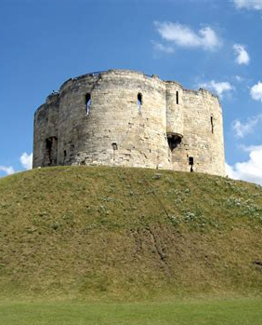
Prior to the Norman Conquest, the main Anglo-Saxon defences were fortified towns known as burhs. The Normans began building motte and bailey castles as soon as they landed on English soil. The map below shows how extensive the Norman castle-building programme was. These castles were not necessarily defensive structures like burhs – they also had the purpose of intimidating the conquered Anglo-Saxons and reminding them of Norman power. They were built in locations of strategic value and could be built very quickly – some early wooden motte and bailey castles could be put up in just a few days. In the first years of the Conquest, William often ordered castles to be built to secure towns that had submitted to his power. Wooden motte and bailey castles had obvious disadvantages, as wood could rot or burn. Over time, wooden motte and bailey castles were often replaced with more permanent stone structures, although these were expensive to build and maintain. The most visible part of a stone castle was the central tower. These were high and built on raised ground. This meant that they could be seen from a large distance away and demonstrated the power of the Normans. It also meant that it was almost impossible to attack the castles without warning, and archers had excellent defensive positions from which to resist any enemies.
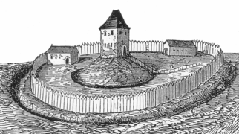
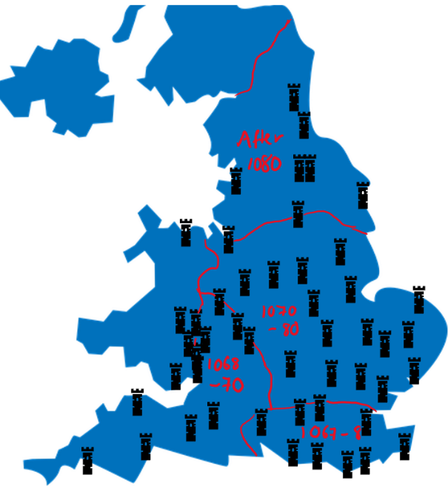
Images: map showing all the castles built by the Normans up to 1086 – Holly Hiscox; wooden motte and bailey castle – https://commons.wikimedia.org/wiki/File:Motte_Strichzeichnung.png; York Castle stone tower today – https://commons.wikimedia.org/wiki/File:Tour_Clifford_York_41.jpg

TASK 1: In full sentences, explain how building castles helped the Normans to conquer England.

