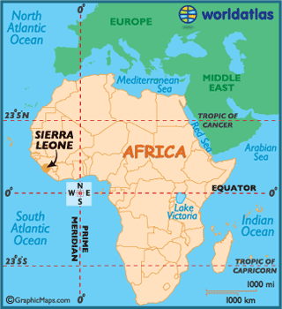
Mary Smart
Mary Smart was born in Sierra Leone in 1832.
In the 1780s, the British created a settlement in Sierra Leone, the ‘Province of Freedom’, where they resettled the ‘black poor of London’. After the abolition of the slave trade in 1807, British ships patrolled the West African coast for illegal slave ships, and any that were captured were taken to Sierra Leone. In the 1800s, freed Black Americans and West Indians also immigrated and settled in Freetown in Sierra Leone.
Source: www.worldatlas.com/webimage/countrys/africa/sl.htm

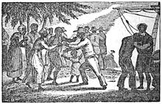
Mary Smart’s grandfather was a recaptured slave who had been taken to Sierra Leone. He settled in a town called Regent and became a devout Christian. He raised his daughters and granddaughters as Christians.
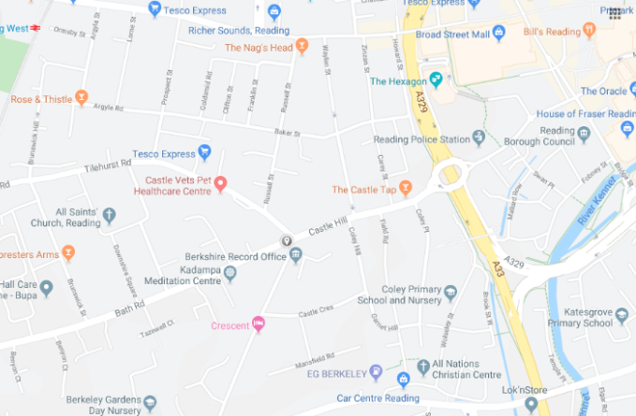
Mary Smart was chosen as one of the young women to be sent to train as a teacher in England. She came to a branch of the Church Missionary Society in Reading in 1848. She lived in a religious house called Bath Cottage on Bath Road. In this community, she was taught how to teach others, intending to return to Sierra Leone as a missionary.
Source: Google Maps

Image of liberated slaves arriving in Sierra Leone (Source: https://en.wikipedia.org/wiki/Sierra_Leone#History)

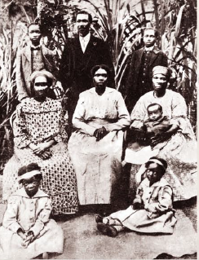
Unfortunately, Reading in the early 1800s was much like other big towns and suffered from outbreaks of disease, especially cholera because of the lack of sewage systems. In the summer of 1849 there was an outbreak that killed thousands. On 11 September 1849, Mary Smart died of a disease that caused serious inflammation of the skin. She was buried at Cemetery Junction. At this time a grave cost £6 and 3 shillings, which her friends in the religious house paid for her. However, they could not afford a headstone, so her grave is unmarked. Records of her burial describe her as a ‘pious African girl’. Her grave is next to a native Australian boy, Willie Wimmera, who was also brought to Reading to train as a missionary. He died at 11 years old of tuberculosis.
Members of the Okrafo-Smart family in 1919. Many of the family joined the medical profession. (Source: http://www.antislavery.ac.uk/items/show/34)

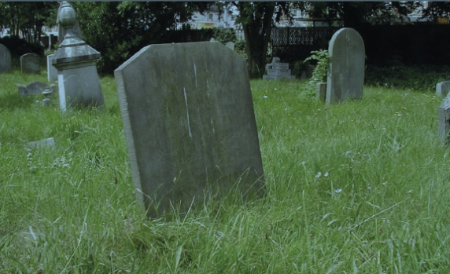
Today there are over 600 Sierra Leonians in Reading, but Mary was the first person born in Sierra Leone to come to Reading.
Tombstone of Willie Wimmera (Source: http://www.antislavery.ac.uk/items/show/34)

Members of the Okrafo-Smart family in 1919. Many of the family joined the medical profession.

