The Central Club Black History Mural
The Central Club, the Black community centre in London Street, was closed at the end of 2005, but the mural along its Mill Lane wall is one of Reading’s landmarks and continues to tell the story of 4,000 years of Black history, from ancient Africa through years of struggle for freedom, justice and equality. It was completed in 1990 but the story does not end there. The last panel shows the choices to be made in the future: religion, education, sport and the ballot box, versus drugs and the gun.
Source: www.getreading.co.uk/news/local-news/gallery/angles-reading-central-club-mural-8854439
The idea for the mural was first raised in 1987, when Clive Saunders was manager of the Central Club, to engage with local people and instil a feeling of pride in the Black community.
The council was approached and a group set up, which led to the council commissioning the mural, which was funded partly by charity and partly by the council itself. There were many supporters, including Reading people from both the Central Club and the Apollo Club – several of whom appear in the mural – and Tony Durant, then MP for Reading West.
Because Mill Lane was a highly visible site, it was important to have top-quality artwork, so professional artist Alan Howard was engaged. He and his team from the Central Club – Patrick Dawkins, Wayne Edwards and Kevin Taylor – did the painting.
The Mural Group that was set up decided who to include, did the research and consulted widely within the community, including the shopkeepers along London Street. Decisions about who and what to include were not always unanimous. Particularly contentious were the list of black people killed in police custody, the gun and the syringe. At one point the gun and syringe were actually painted out altogether, but a group of dissenters climbed up and painted them in again, where they still remain.
Source: www.getreading.co.uk/news/local-news/gallery/angles-reading-central-club-mural-8854439
The final line-up includes great figures from Black history and local people from Reading.
During Black History Month 2006, Reading Central Library tried to put names to as many people as possible, but there are several gaps.
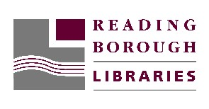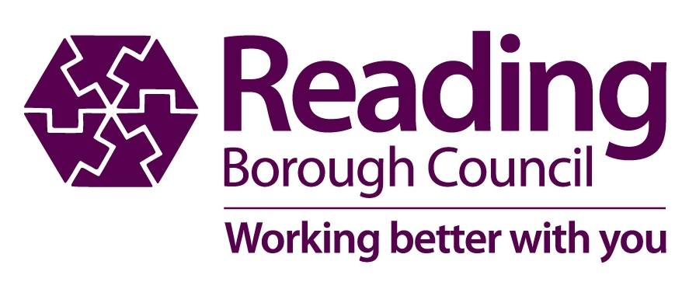The information here is based on a Black History Month display in Reading Central Library in 2006. Many thanks to the people who helped: Esther Augustus, Tammy Bedford, Shirley Graham-Paul, Alan Howard and Clive Saunders.

