Resource sheet 5.1C
EVIDENCE PACK

Source A
A map showing the events at Imjin River, 22–25 April 1951.
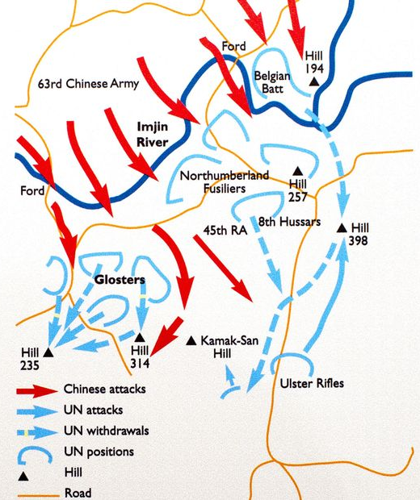

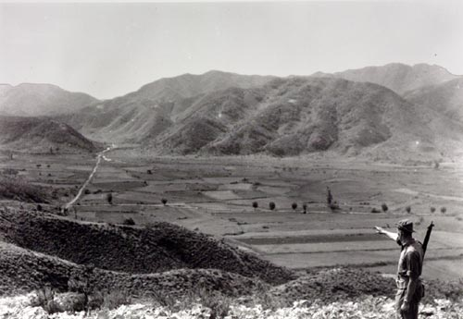
Source B
Photo taken five weeks after the Battle of the Imjin River. It shows a Gloster pointing to the main route through the valley. He is standing on Hill 94 and pointing to Hill 235 (the ridge on the left), where Chinese forces attacked the Glosters during the battle.

Image © IWM BF 10277

Source C
Photo taken five weeks after the Battle of the Imjin River. This photo shows Hill 235, to which the Glosters were forced to withdraw and which they held for over 24 hours without support while under constant attack from the Chinese. Notice how the vegetation has been trampled. Holding this hill allowed the rest of the 29th BIB and UN forces to withdraw and regroup to stop the Chinese advance. Over 500 Glosters were taken prisoner when they attempted to retreat from Hill 235 on 25 April.

© IWM BF 10280
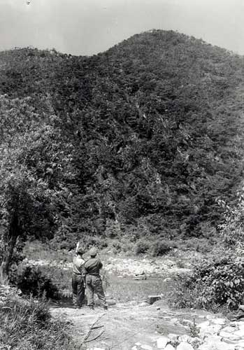

Source D  Tommy Clough, 170th Mortar Battery, fighting alongside the Glosters in the 29th BIB.  ‘On the night of the 22nd April, all hell broke loose. My commanding officer handed me his binoculars to have a look and I couldn’t believe my eyes. There were literally thousands of them – Chinese and North Koreans. That’s when I know we were in trouble. One of the lads said to me “are there many of them?” and I couldn’t tell him the truth because I didn’t want to spread alarm.’ | Source E  Private Anthony Eagles, 1st Gloucestershire Regiment, recalls orders on 25 April. He was captured by the Chinese and kept as a prisoner until the end of the war in 1953.  ‘At 10 am we were told we were chosen to stay on Hill 235 [with the wounded] and give cover fire as the others went out [retreated]. I only had about three rounds and the others were in a similar state. So we loosed off one shot here and one there, just moved around to make them [Chinese] think there were more of us. When we finished, we smashed up our rifles [so that the enemy would not get them if they were caught].’
Source F  John Dyer of Twyford, Berkshire, then a 20-year-old serviceman with the Royal Ulster Rifles.  ‘I have never seen so many troops in my life. The hillside was literally covered in them. If you’ve ever seen a film when lemmings go over a cliff, it was just like that. Then we realised that we were in trouble. The courageous Chinese foot soldiers fought almost suicidally when they saw survivors escaping on tanks. The tanks were going straight through them [Chinese soldiers]. And that’s all I could hear, these people screaming, being crushed by the tanks. Quite a horrible experience.’ | Source G  Captain Anthony Farrar-Hockley, a young Glosters adjutant (aid to a commanding officer), recalled the last hours before the attack on 22 April.  ‘The Glosters were holding an ancient invasion route to Seoul – the key ford across the Imjin River where vehicles could cross. On the day of the 21st, we saw lots of little groups of the enemy getting into position.’

Source H  On 8 May 1951, this American Presidential Unit Citation was awarded to officially recognise the bravery of both 1st Battalion, the Gloucester Regiment and C Troop, Light Mortar Battery, Royal Artillery.  ‘The above are cited for exceptionally outstanding performance of duty and extraordinary heroism in action against the enemy on the 23rd, 24th and 25th of April, 1951. They were defending a very critical sector of the battle front during a determined attack by the enemy. The defending units were overwhelmingly outnumbered.  Their heroic stand provided the critically needed time to regroup other units and block the southern advance of the enemy. Time and again efforts were made to reach the battalion, but the enemy strength blocked each effort. Without thought of defeat or surrender, this heroic force demonstrated superb battlefield courage and discipline. They displayed such gallantry and determination in accomplishing their mission under extremely difficult and hazardous conditions as to set them apart and above other units participating in the same battle.’ | Source I  There was an investigation to see whether all was done to prevent the capture of the Glosters. This is an extract from the report, showing attempts to relieve the Glosters and the order for retreat.  ‘Heaviest attack was against the 29th BIB. They were forced to withdraw under heavy enemy pressure. The Gloucester Battalion received heavy attacks throughout the night of 23–24 April. M-24 tanks moved out in the morning of 24 April to link up with the Gloucester Battalion and aid its withdrawal. They met heavy resistance, the lead M-24 tank was hit and blocked the road. The brigade commander considered it unwise to continue the effort to relieve the Gloucester Battalion and withdrew the relief force.  The US forces ordered Plan Golden A which called for all troops to withdraw. The problem of relieving the Gloucester Battalion remained unsolved. Two attempts by tanks failed, so the commander, to save the rest of the unit and comply with the order to withdraw, ordered the Gloucester Battalion to fight its way out and the 29th BIB began its withdrawal.’

Source J  This is a record of a conversation between 29th BIB commander Brigadier Thomas Brodie and American Major-General Robert Soule. Brodie contacted Soule by radio on the 24th. The famous exchange shows how miscommunication can happen. It also helps to explain why the Glosters were left without relief until it was too late for them to retreat safely. (From Forgotten Heroes – Korea Remembered, BBC documentary, 2001)  ‘Brig. Brodie informed Maj-Gen Soule that the 29th BIB had inflicted heavy casualties on the Chinese forces.  Maj-Gen Soule asked, “How are things with the Glosters?”  Brodie replied, “A bit sticky, things are pretty sticky down there.”  Brodie meant that the Glosters were in a hopeless situation, but Soule interpreted Brodie’s comments as not being too desperate so he ordered the Glosters to “hold fast and await relief the next morning”.  Relief did not come and what was left of the Glosters attempted to retreat the next day (25th April). Most men were captured by the Chinese.’ | Source K  Chinese General Peng Dehuai’s address in preparation for the Spring Offensive, 6 April 1951. Peng believed that the UN forces were even less prepared than the Chinese in April and did not want to lose the initiative. He argued that the Spring Offensive would be the decisive battle of the Korean War and hopefully shorten the war. His orders were for the Chinese to separate and surround the enemy and wipe out whole units.  ‘This campaign is extremely important. We must annihilate a few divisions of the enemy, smash their plans and win back the initiative in the battlefield.  We must concentrate our forces and eliminate separated enemies.’

