Resource sheet 2.2D
What do you want people to remember about the Korean War?
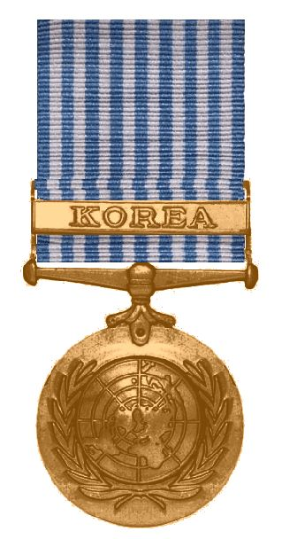
What I most remember about the Korean War is…

I would like other people to know about this because…

