HA Resource Hub Submission Form
Resource Title: Was World War Two Hitler’s fault? |  |  | Age Range: Year 8/9
Author name and email contact:  Sally Burnham  Salburnham@yahoo.co.uk | Resource Details: (e.g. how many documents does it consist of? In which order?)  One PPT  Worksheet – causes worksheet (this document, below)
Necessary prior learning to complete this:  Students would benefit from having studied the Treaty of Versailles, Communism and League of Nations, but this isn’t crucial. |  | What does it lead to next?  World War Two
Explanation: How should this resource be used?
I envisage this task taking at least two lessons. Pupils need to work through the PPT and use the worksheet and complete the tasks on the PPT. I have asked them to work in their books except for the bits that I will mark and my students will email these to me – you may want all the work done online so it can be emailed through.
You may want to break the PPT up into sections so students aren’t faced with all the activities at once.
Hitler
Hitler had set his vision for the future out in his book Mein Kampf that he wrote in 1923.
Key ideas included that the Treaty of Versailles should be cancelled and all the land that Germany had lost should be returned, all German people must live in Greater Germany (this included people in Austria and Czechoslovakia). Germany needed Lebensraum – living space so they could grow food for German people. This meant that Hitler thought Germany should conquer large areas in eastern Europe. Another key idea was that the Germans were the ‘master race’.

What did Hitler do?
1933 – Hitler began building up Germany’s armed forces as soon as he came to power. This was against the Treaty of Versailles. He kept this secret until 1935 but then he no longer hid the rearmament programme.
1936 – Hitler introduced conscription. In March 1936 Hitler sent troops into the Rhineland which again went against the Treaty of Versailles too.
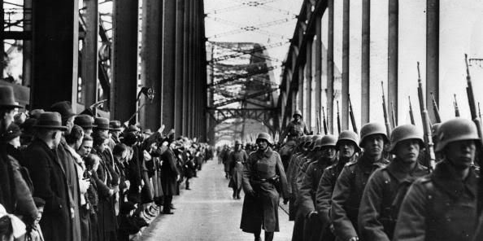
1937 – Hitler sent troops to help Franco in the Spanish Civil War. Many historians think that he did this so he could test out his new aircraft and weapons.
1938 – In March 1938 Hitler joined Austria with Germany (Anschluss). This was also against the Treaty of Versailles.
In September 1938 Hitler invaded part of Czechoslovakia called the Sudetenland. Britain and France met and came up with an agreement called the Munich agreement that said that Hitler could invade the Sudetenland as long as Hitler didn’t invade any more of Czechoslovakia.
1939 – March 1939 Hitler ignored the Munich agreement and invaded the rest of Czechoslovakia.
September 1939 Hitler invaded Poland.
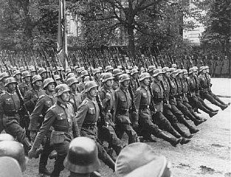

Appeasement
Britain was very keen to avoid another war after the horrors of the First World War and so he worked really hard to prevent the Second World War. He followed a policy called appeasement. He hoped that if they gave Hitler a bit of what he wanted it would stop him making even more demands. This was how the Munich agreement came about – Chamberlain got Hitler to agree that he could keep the Sudetenland but wouldn’t demand any more land. There were celebrations in Britain when Chamberlain came back from the meeting – Chamberlain said the piece of paper that had been signed guaranteed ‘peace in our time’.
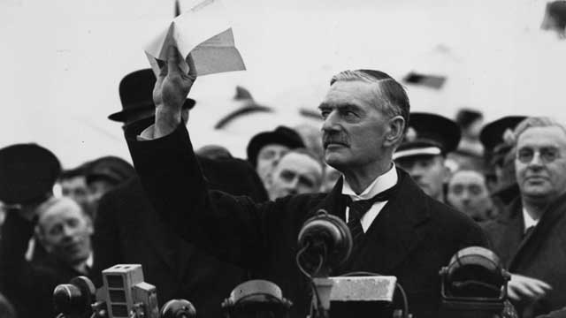
However appeasement failed. In March 1939 Hitler invaded the rest of Czechoslovakia. Historians disagree about whether Chamberlain was right to follow the policy of appeasement.
Appeasement was the best policy | Appeasement was a big mistake
- Britain needed time to build up her weapons, appeasement gave her time to do this.  - Many people were more scared of Communism than the Nazis – they thought Hitler provided a good protection for Europe from Communism.  - Appeasement was fairer than the Treaty of Versailles had been on Germany. | - It gave Hitler the confidence that he could take over whatever land he wanted.  - It gave Hitler time build up his weapons before invading Poland.

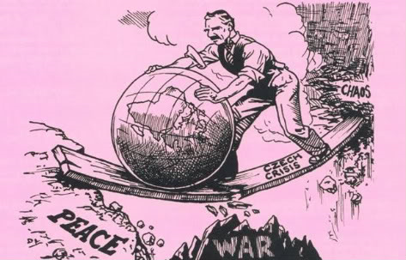
A cartoon showing Chamberlain trying to get the world to peace.

The Treaty of Versailles
Many people in Germany were angry about the Treaty of Versailles that had been signed at the end of the First World War. Germany lost land, her colonies and her army was limited to 100,000 men (enough to stop internal unrest but not enough to threaten other countries). They also had to accept the War Guilt clause saying they had started the First World War and pay reparations of £6.6 billion. This made the German people willing to listen to Hitler when he promised to ignore the Treaty of Versailles.

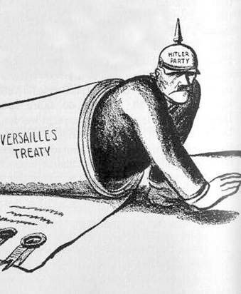
A cartoon showing that the Treaty of Versailles enabled Hitler to gain support.

The failure of the League of Nations
The League of Nations was set up after the end of the First World War. It was the American president, Woodrow Wilson who suggested it. He wanted to have an organisation where countries would meet to discuss problems so that they could avoid another war. However the League of Nations had many weaknesses and by the 1930s it wasn’t strong enough to stand up to dictators like Mussolini and Hitler. In 1935 Mussolini, the Italian dictator, invaded Abyssinia but the League of nations failed to stop him. Some historians argue that this made Hitler think he could get away with doing the same thing in Europe. Whilst European countries were occupied by Mussolini, Hitler re-occupied the Rhineland. The League of Nations did nothing about Hitler breaking the Treaty of Versailles.
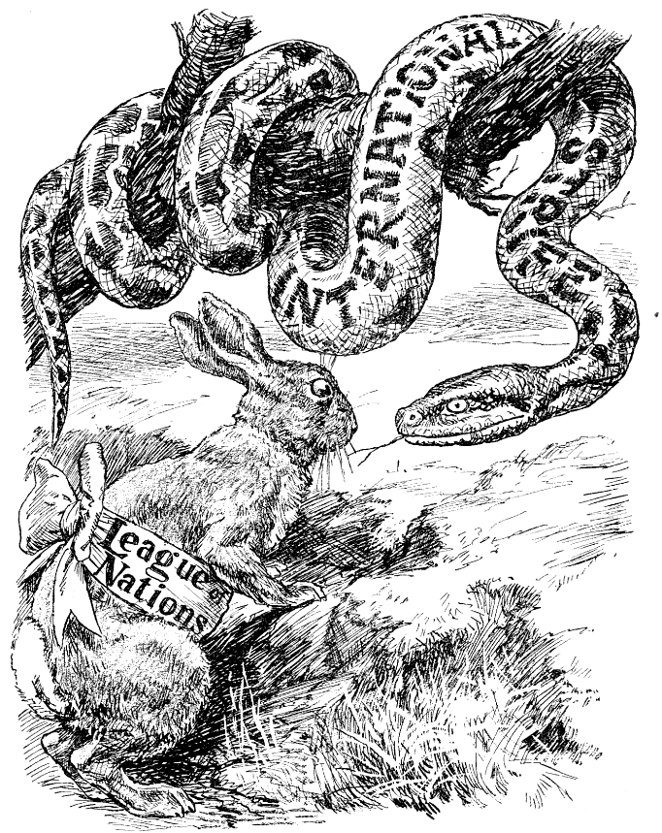
A cartoon showing how weak the League of Nations was.

American policy of isolationism
Even though America had come up with the idea of the League of Nations, the people in the USA didn’t want to be involved with European politics anymore. They felt that they had lost a lot of young men in a European War (WW1) and didn’t want to be involved anymore. This policy was called isolationism. Hitler knew that America (the only country strong enough to stop him) would not get involved.
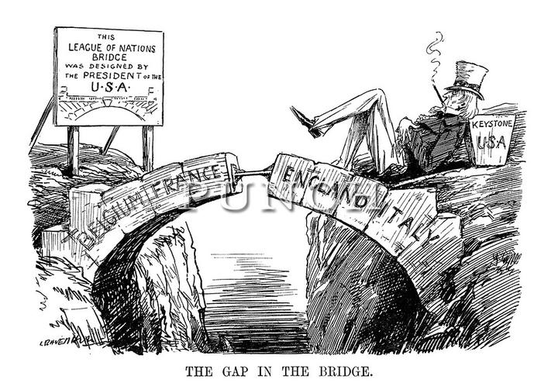
What does this cartoon suggest?

The Nazi-Soviet Pact
This pact is sometimes called the Ribbentrop-Molotov Pact and was signed between Russia and Germany in 1939. The pact said that Hitler and Stalin (leader of the USSR) would not fight each other. The leaders hated each other and their policies but Stalin wanted more time to prepare for war and Hitler remembered what had happened in WW1 when Germany had been fighting a war on two fronts (against France and Russia). Hitler thought he could beat France and Britain and then would turn on Russia.
