HA Resource Hub Submission Form
Resource Title:  A History Mystery – Why did 90% of the Maya disappear around 900AD? |  |  | Age Range: Key Stage 2
Author name and email contact:  Alf Wilkinson  Sue.alf@btopenworld.com | Resource Details: (e.g. how many documents does it consist of? In which order?)  One document with 2 activities
Necessary prior learning to complete this:  Children will need to know about the Maya – where they lived; how they lived; how they adapted to life in the rain forests of Central America |  | What does it lead to next?  Exploration of the Maya after 900AD - the new cities in the Yucatan; the arrival of the Spanish and their impact; and the Maya today – what can they tell us about the Maya of old?
Explanation: How should this resource be used?
This resource is an attempt to begin to think about interpretations – what Historians say, where they get their ideas from, and why they differ.
In effect, the children are offered seven different versions of what happened to the Maya – some overlap, like drought and deforestation – some are very different. Of course which one you believe depends on which evidence you choose to use to support your idea.
The beauty of this exercise is that there is no one correct answer – the balance of argument amongst historians is, as I state at the end, that drought was the main cause of the disaster, but no-one is totally sure.
Carrying out this activity should help the children realise there are multiple versions of history, and it is not always clear which is the most likely explanation!

A history mystery: Why did 90% of Maya ‘disappear’ around 900AD?
The Maya were one of the most successful Meso-American societies before the Europeans landed in America. By 900AD there were probably 7 million of them living in 30+ separate city-states. Some of the cities were huge – containing 50,000 people or more, - and it is the remains of many of these cities that we find in the jungles of Central America today.
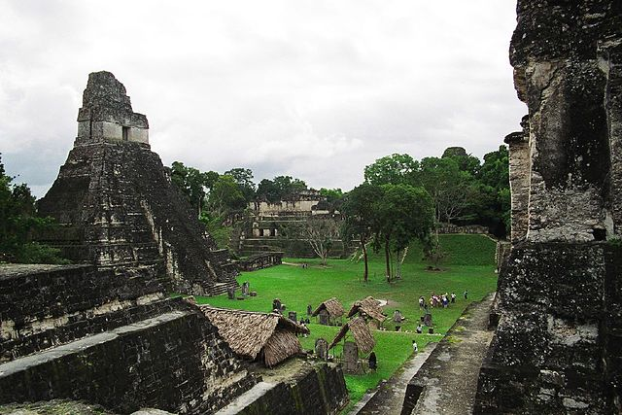
Picture of Temple I in Tikal, Guatemala, taken by Bruno Girin https://commons.wikimedia.org/wiki/File:Tikal_temple_jaguar.jpg

The Maya were a stone-age society, dependent on stone for tools and weapons, yet they managed to build huge temples and pyramids. They had no form of wheeled transport, yet their roads criss-crossed the continent, all goods like salt and obsidian, [a volcanic rock that could be sharpened into a blade for tools and weapons], carried on the backs of porters. They were an agricultural society, dependent on crops, living in the rainforest, and managed to create huge wealth from their surpluses.
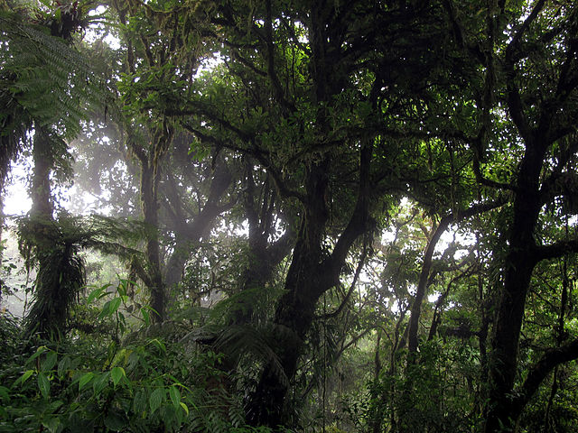
Central American rainforest: Monteverde Cloud Forest Reserve in Costa Rica (by Haakon S Krohn) https://commons.wikimedia.org/wiki/File:Monteverde_bosque.jpg
Yet in around 900AD, most of the Maya disappeared from the historical record. Many of their cities were deserted. No more stelae [special commemorative columns] were built after 845AD. It is a real history mystery. Historians disagree about the reasons. There are many interpretations of events at the time. [Interpretation: one historian’s idea or argument as to what happened, based on the evidence they have found and used.] Here are some of the different interpretations used by historians to try to explain the mystery of the disappearance of most of the Maya around 900AD. You could probably discover many more if you search on the internet!
- Drought. There was a long drought in the region, from around 820 AD to about 940 AD, and again from around 1000AD to around 1100 AD. The Maya were using more water than was falling as rain. This meant they were unable to grow enough food to feed everyone, so many people starved, or moved out of the cities into the countryside to try to grow their own food.

- The actions of rulers of the cities. Some historians say there is evidence that at this time cities were competing to build the biggest, the tallest, the grandest pyramids and temples. This meant thousands of men were building instead of farming, so not enough food was grown, leading to starvation and death for many.

- Cimate change brought on by rising sea levels. There is some evidence to suggest that at this time sea levels in the area rose, as ice at the poles melted. This forced coastal people further inland, putting more strain on farming and cities.

- Force of nature. Some historians suggest an earthquake or volcanic eruption, such as the one that destroyed Ceren in 590 AD, might have disrupted trade and farming and killed thousands of people.

- Climate change brought on by deforestation. Some historians argue that Maya cities had become too big. By chopping down so many trees for farmland, and using so much water, the Maya changed the climate, making it hotter and drier.

- Warfare. The Maya were made up of 30+ city-states who were often fighting each other. Cities grew when there was a strong king, and shrank when there was a weak ruler. The destroyed city of Yaxchilian, for example, has been excavated and in one small area over 200 flint spear or arrow-heads have been found clustered around an entrance to the Palace - clear evidence of a battle. Warfare disrupted trade so people starved to death.

- The Maya were just too successful! Because the Maya were clever, inventive, and good at farming, they became rich. Rich cities grew bigger. Perhaps, by around 1000AD, there were just too many Maya in the area.

Activity 1:
From what you know about the Maya, which of these explanations do you find most convincing? Does any single interpretation explain what happened to the Maya at this time? Where might you find the information that will help you to decide what happened to the Maya? Perhaps you agree with none of these interpretations, and have ideas of your own? Decide why you think many Maya cities were abandoned around 900AD.

Activity 2:
Some historians think 90% of the Maya died [‘the Great Disappearance theory;’] others think they survived, but moved to another part of what is now Mexico, the Yucatan, to start all over again [‘the Great Descent’ theory.] Which of these do you think is accurate? Can you discover any evidence to support your idea? One thing is certain, when the Spanish came to Central America in the 1500s there were again millions of Maya, and even today there are between 7 and 8 million Maya in the region.

A final note [not to be read until the activity has been completed!]:
Many historians, but not all, now think that the catastrophe that affected the Maya around 900AD was caused by drought. There simply was not enough rainfall to maintain their lifestyle or agricultural production. How does this idea agree with your reason for the decline of the Maya?

Alf Wilkinson, April 2020

