HA Resource Hub Submission Form
Resource Title: Take one image- Viking times |  |  | Age Range: 8-11
Author name and email contact:  Paul Bracey  Paul.Bracey@northampton.ac.uk | Resource Details: (e.g. how many documents does it consist of? In which order?)  A4 Activity sheet (Resource 1)  You need a primary school history textbook (easily purchased online) or website related to  The Vikings -include towns, trade, artwork, village life to show that focusing on raids does not tell us everything about them  Haswari, R.(Ed) (2018)Find out ! The Vikings. New York: Penguin Random House  https://www.bbc.co.uk/bitesize/topics/ztyr9j6
Necessary prior learning to complete this:  Nothing required  However, it is appropriate to say something about re-enactments. They are very popular both in schools and with organisations such as English Heritage and are great fun. However, we need to ask ourselves how far a re-enactment tells us about the time especially as it typically focuses on one event. |  | What does it lead to next?  You could look at aspects of the time of the Vikings in depth.
Explanation: How should this resource be used?
Step 1: Share the question - your child is going to look at a picture and decide how well it tells them about when the Vikings lived.
Step 2: Ask your child to put aside anything they know about the topic and look at the picture and pick out the 3 adjectives which sum up what it tells us.( The picture is a role play event of a Viking battle with the Anglo-Saxons)
Step 3: Your child should justify their choice of words on the sheet
Step 4: Find out what you child knows about this time and how well they think the picture sums up what life was like for everyone.
Step 5: Spend the next few hours or days reading/find out about the lives of different people's lives in and events in Viking times. Here are some suggestions
- the Vikings as raiders and invaders e.g. battles with the Anglo Saxons
- the Vikings as explorers, traders and craftsmen
- the lives of different men and women in Viking times - jobs, homes, towns and countryside
You do not have to cover everything about the time but enough to show something about the lives of different people.
Step 5: Go back to your sheet and ask your child to look back at the picture again and decide how far they think it sums up the lives of people at the time. Ask them if they have changed their mind and why.
Special note: You can use this approach with any topic - however it needs to be followed up by looking at different peoples' lives at a that time.

Take one image - How much does this photograph tell us about the Vikings?
.
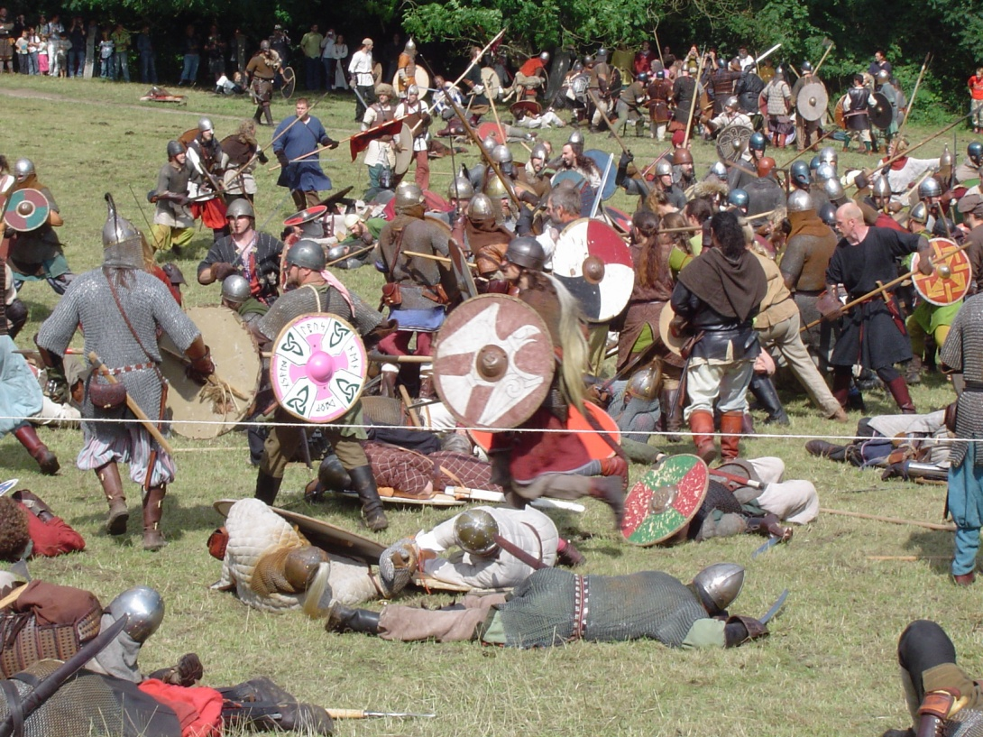
https://commons.wikimedia.org/wiki/File:Vikings_fight.JPG
GNU Free Documentation License.

Re-enactments are role play activities in which people pretend to be living during a period or event in the past. What does this picture suggest? Look at the word below and decide which three sum up the picture and complete the sentences below-

Rich poor colourful fun dangerous

happy sad busy nice horrible
Any word or words which you would prefer..................................

1. I have chosen................... because......................................................................................
2. I have chosen....................because........................................................................................
3. I have chosen....................because............................................................................................

Activity 2: Now find out about the time when the Vikings lived using a textbook or website

Activity 3: How well does the photograph sum up the time of the Vikings? Choose one of the following
- very well
- partially
- not at all
Complete the following but avoid copying information from texts
I have chosen ...................................................because...............................................................
......................................................................................................................................................
........................................................................................................................................................

Have I changed my mind since activity 1? Give a reason for your decision
...............................................................................................................................................................
................................................................................................................................................................
..................................................................................................................................................................

