HA Resource Hub Submission Form
Resource Title: Time Traveller’s Guide to 15th century York |  |  | Age Range: KS3 or KS4
Author name and email contact:  Helen Snelson  enquiries@history.org.uk | Resource Details: (e.g. how many documents does it consist of? In which order?)  A booklet of 13 pages
Necessary prior learning to complete this:  None |  | What does it lead to next?  Students can learn about life in a medieval city from this booklet.
Explanation: How should this resource be used?
This is a booklet written in the style of the Ian Mortimer ‘Time Travellers’s Guide’. By reading it students can learn about a later medieval English city. As such it is useful for sense of period work at KS4 ready for the GCSE thematic medieval section. At KS3 you can set students questions on the booklet so that they learn about medieval town life.

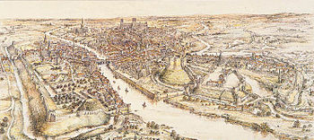

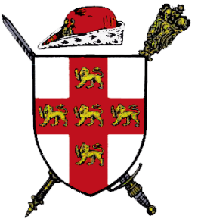
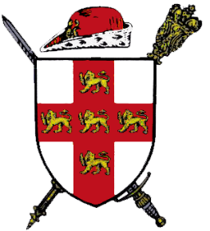
Presents
The Mount School
A Time Traveller's Guide to Medieval York 1415
Time traveller’s guide to York in 1415

Arrival

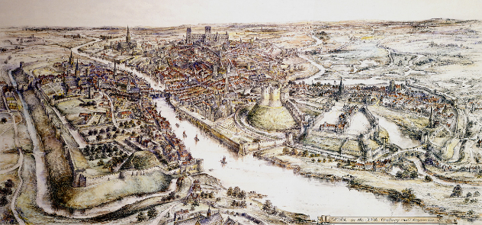
The wind in our faces means that the first thing that hits me as I approach the bustling city is the smell of pungent rotting meat mingled with the smell of decaying faeces, human and animal alike. The smell of raw fish in the heat of the hot summer’s day makes me feel rather ill.

As our boat slowly approaches the great crane, the sails billow out around us. The warehouses that border the river, tower above our small wooden boat, filled to the brim with goods such as cloth and even a small quantity of sea salt. The wonky, uneven wooden buildings along the staithes contrast with the beauty of the stone wall of the Franciscan friary across the river. Ahead of us the city's only bridge is a tangle of buildings. Our York boatman has proudly pointed out the new public lavatories installed on the bridge, despite this the river flows well, and I am assured that the city's drinking water supply is as fresh as any to be had.

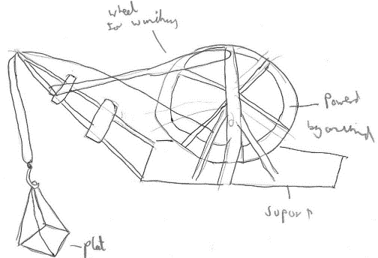
The great crane, about which I have heard so much, has a large wooden wheel turned by a donkey on a treadmill. After the loading platform is lowered towards us, we load up our cargo of cloth. Our cloth is swung ashore and assessed for customs dues by the city's officials. We declare the salt, but do not allow it out of our sight. Such a precious commodity should not be left unattended in a strange place.

I clamber ashore and take in my surroundings. Cream and brown wattle and daub houses line the squelching, uneven cobbled roads that twist and turn, leading somewhere I don’t know. The river banks are slippery with mud from boats being hauled out of the river. Along the river bank people are disposing of their waste. The stench of rotting meat and decaying faeces hits me again, but even worse this time.

A small, stick-thin man dressed in grey and beige un-dyed cloth, tinted brown from its regular use, limps past me. Unbrushed, untamed hair tangles in knots around his face and his yellowy-brown teeth are set in a grin as he hobbles slowly through the uneven streets accompanied by an even thinner woman. Their sweat and dirt invades my nostrils.

My string of thoughts is interrupted by a plump man with dirty hands and bitten finger nails wearing a crooked grin, showing off his yellow, worn-down teeth. His grey tunic is covered in stains of an array of colours. He asks me if I want to buy one of his pies while eying up the precious salt securely attached to my waist by a leather belt. I refuse the pie and swiftly move on.

A man and woman dressed in deep blues and reds walk passed proudly. The man is plump and the lady is beautiful with a gold chain around her neck and an elegant flowing dress. They are followed by a servant carrying their bags and trying to keep up.

Then I look up and see it, the pride of the city. It’s gorgeous, it’s mesmerising! Towering above the small town houses made of wattle and daub, gracing the sky line with its presence. The spires of churches reach high, but it reaches higher. Clifford's Tower is magnificent, but this is even more magnificent. There it is in all its glory, the still to be finished, York Minster.
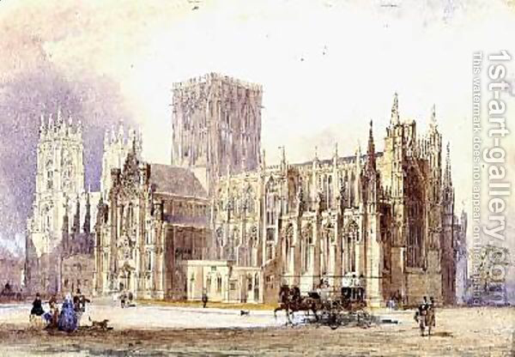

A Time Traveller’s guide to York in 1415

To a home

As we make our way from the river we see a larger number of the richer citizens of the city, and I stand out like a sore thumb. A sly looking merchant approaches me with a crooked smile and a cunning glint in his eyes. He immediately offers an unreasonable price for the 30 ounces of high quality salt. Obviously I rejected the offer without a second thought.

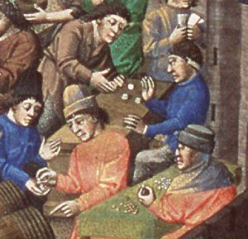
The trader then says that he will lead me to the Merchant Adventurers’ Hall and will introduce me to some of the traders for a margin of our profits. I once again pass a range of York’s vibrant population. Beggars in torn, dirty robes push past us, while the stocky upper class haughtily stride about their business. The further we get into the city the more merchants we see in amongst the general mass of people. After a while we arrive at the impressive Merchants’ Hall.

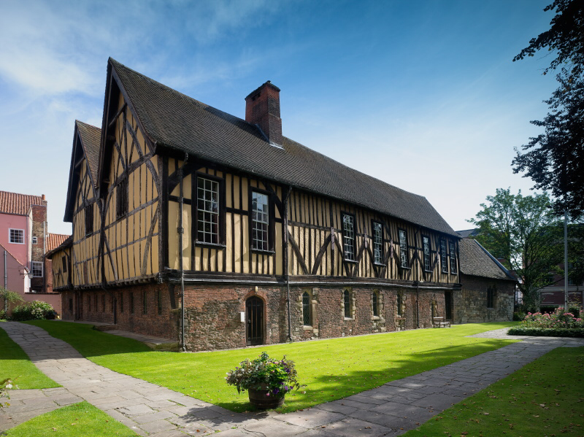
As if I hadn’t already realised the importance of York, this building makes clear the true importance of the city. The two levels that make up the building cause it to rise above the surrounding area. A small stone chapel connected to the side of the main building proudly displays the merchants’ commitment to God and the teachings of the church. As we enter the ground floor we are bombarded with the sights and sounds of a crowded room, full to the brim with beggars and other lower class citizens looking for the famous hospitality. Our merchant swiftly guides me through this crowded area, up some grand wooden stairs to the first floor. Here there is a drastic change in atmosphere.

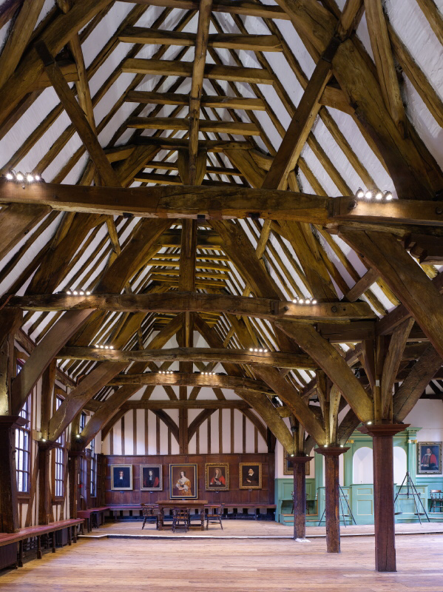
This hall is extravagantly decorated, filled with merchants and traders haggling for the best deals. Here my guide proceeds to lead me towards a small group of similarly dressed merchants. Before I can follow him, a relatively well dressed man makes his way through to the crowd to me. He introduces himself as a customs man who carries out his work at Micklegate Bar, taxing visitors and travellers as they enter into this great fortress of a city.

Upon seeing this man, a merchant quickly bustles up to us and gives the customs man a firm glare. This look is promptly returned as the customs man introduces himself as Jonathan Hyrst. Hyrst is around 5 foot 5 and is obviously in control of some sort of wealth as he is well built and wearing a red silk cape.

The merchant now completely ignores Master Jonathan, and after introducing himself as Nicholas Blackburn, informs me about a deal he knows of that could grant us a great profit.

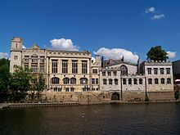
I follow him out of the Merchant Adventurers’ Hall, across the streets, down towards the river to the common Guildhall by the river Ouse. Nicholas Blackburn explains that the deal will take place with a very important person in the Guildhall. It is the hall where the separate guilds congregate. Once we arrive, I see a man who is very extravagantly dressed with a round face, large belly and an unbalanced walk. To his right is another pudgy man with a carpenters’ guild shield on his robe. As they approach me Nicholas embraces the larger man, and introduces him as his father, James Blackburn.

James’ companion quickly identifies himself as head of the carpenters’ guild before making his excuses. He must go to assist his guild in the creation of its Corpus Christi play.

Left alone with James and Nicholas Blackburn, who seem to be quietly discussing some matter between themselves, I look around the hall and take in a grand, high-ceilinged space, with important people going about their business. Some were giving us odd looks. Maybe newcomers to York were not expected to immediately make their way here.

My observations are cut short as James questions our price for the salt in our possession. After considerable haggling, we agree on the more than reasonable price of 30 ounces of gold for 30 ounces of salt. This either must have been a worse deal than we were aware of, or we were particularly charming that day, as shortly afterwards Nicholas and his father invited us to their house for dinner. Another short walk across the city led us to a fine merchant's house.

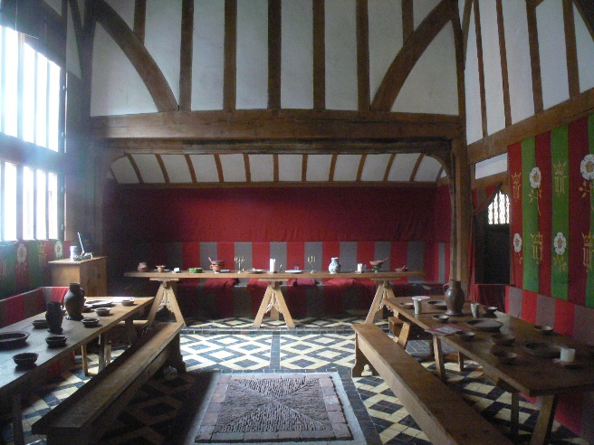
We sit in the dining room while servants enter with bowls of water to wash our hands. They then bring the entreé. It is a sweet dish made of dried dates and figs with a generous glaze of honey. This is followed by a wide range of pies. For the main course the servants bring a massive helping of lamb and veal, which leads to a grand finale of cheese, grapes and a fine Italian wine.

After this fabulous dinner the Blackburns offer to host us for the night, and tired from our long days we graciously accept.

A Time Traveller’s Guide to York in 1415

To a Mass

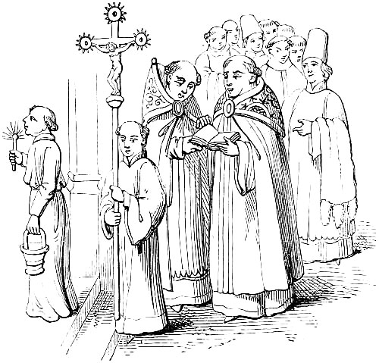
Early in the morning we head to the Blackburn’s much loved church of All Saints’ in North Street for morning mass. Located near the River Ouse, it is rather ordinary and doesn't stand out from the other 47 churches you can choose to pray in. Although it is no match for the Minster, the local limestone is beautifully crafted with magnificent stonemasonry skills. As we enter I instantly notice the pleasant scent of burning incense, masking the smell of unwashed bodies. However, the open sewer which had previously run through North Street, had been covered by large stone flags, charitably funded by the Blackburn family. As people slowly start filing in for mass, it feels as if the church is filling up quickly. Master Nicholas tells me that due to a lack of funding and a small plot when the church was built centuries ago, 2 feet were deducted from the standard width of most churches across England. I judge that the church is about 14 feet across which is still enough space for the sizeable congregation, however we aren’t packed in with the masses, as the Blackburn's are wealthy enough to have their own chapel separated for them at the side of the church. A dirty beige tiled floor conceals the bodies of the previous Blackburns.
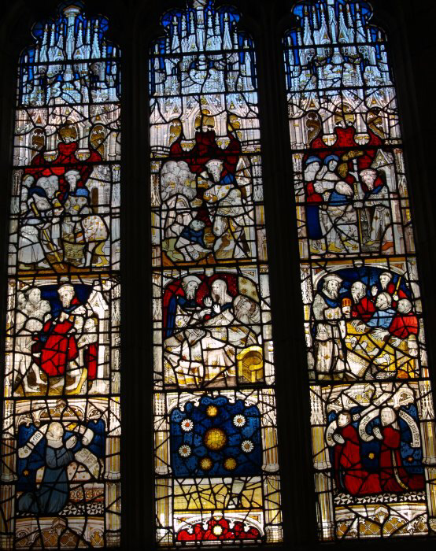
The first window which catches my eye is the one that is being constructed thanks to donations from the Blackburn family. Master Nicholas explains that the window represents all of the charitable acts which the Blackburn family are doing throughout the city. They want to show their piety and earn a place in heaven, and encourage others to do the same. The window has a number of vivid and colourful images, which show many different charitable acts from caring for the sick and helping the poor, to visiting prisoners. I’m amazed by the intricate detail of the window, and the faces are particularly detailed. I had no idea that the people of York had so much skill. The Blackburn family have told me that they believe that by doing all these good works for the people, years will be taken off their time in purgatory, which I still find slightly odd. Religion and church seem such a central part to everything people do here.

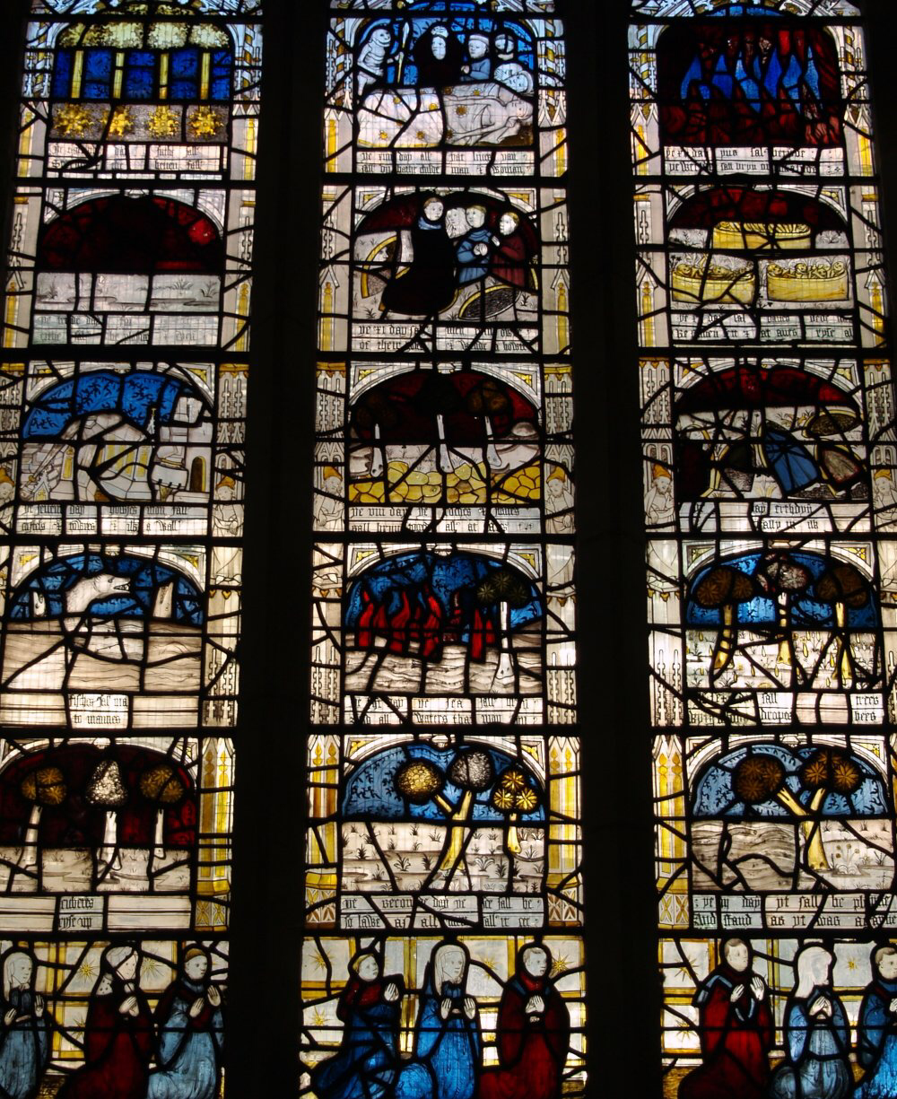
Next to this window there is another, showing what the people believe the day of judgement will be like. The window shows natural tsunamis, famines and disease raging across a hapless Earth; there is text under every picture to explain the dramatic events, and the bottom of the window shows 9 desperate people praying. There is a strong belief that the day of judgement is coming in 1500, which is only 85 years from now, and so people are determined to do as much good as possible in order to redeem themselves. It is explained to me by a well-dressed man with a rich tunic covering his wide girth, and a scabbard hanging by his side, that people are born with natural sin because of the trespass against God’s will in the garden of Eden.

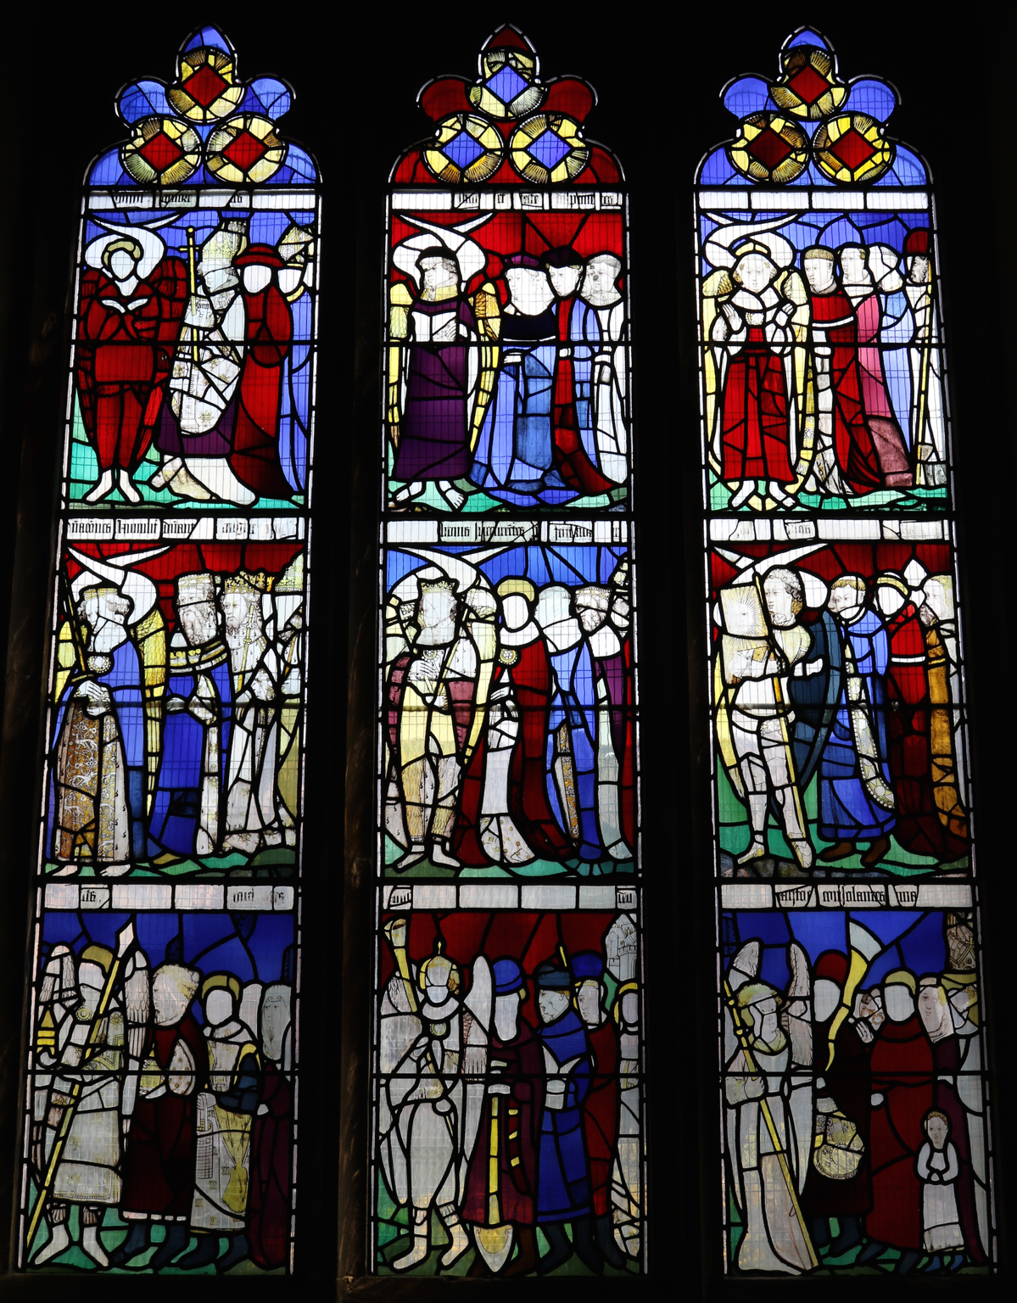
Master Nicholas is just beginning to explain another window to me. It shows nine ranks of angels. It’s quite surprising, as the King is presented in a lower rank than those who work within the church, such as archbishops and monks. By now I’m beginning to realise how important the church really is to these people, and that it is a vital part of the lives of every single person.

The service is beginning but it's being presented very quietly and in Latin and I wonder who can actually understand it. The priest drones on, his monotonous voice creating a constant backdrop. Most people are beginning their own prayers, and some are gathering around windows, the images displayed on these are just as productive teachers as the priest’s homily. Master Nicholas is telling me that it is Corpus Christi, a holy day, which is dedicated to celebrating the body of Christ. That explains the decorations on many of the houses. Master Nicholas is finishing his prayers, and as we watch the elevation of the host, he says we can go and explore the city and watch the Corpus Christi plays instead of staying to share the body of Christ among the people.

A Time Traveller’s Guide to York in 1415

To the plays

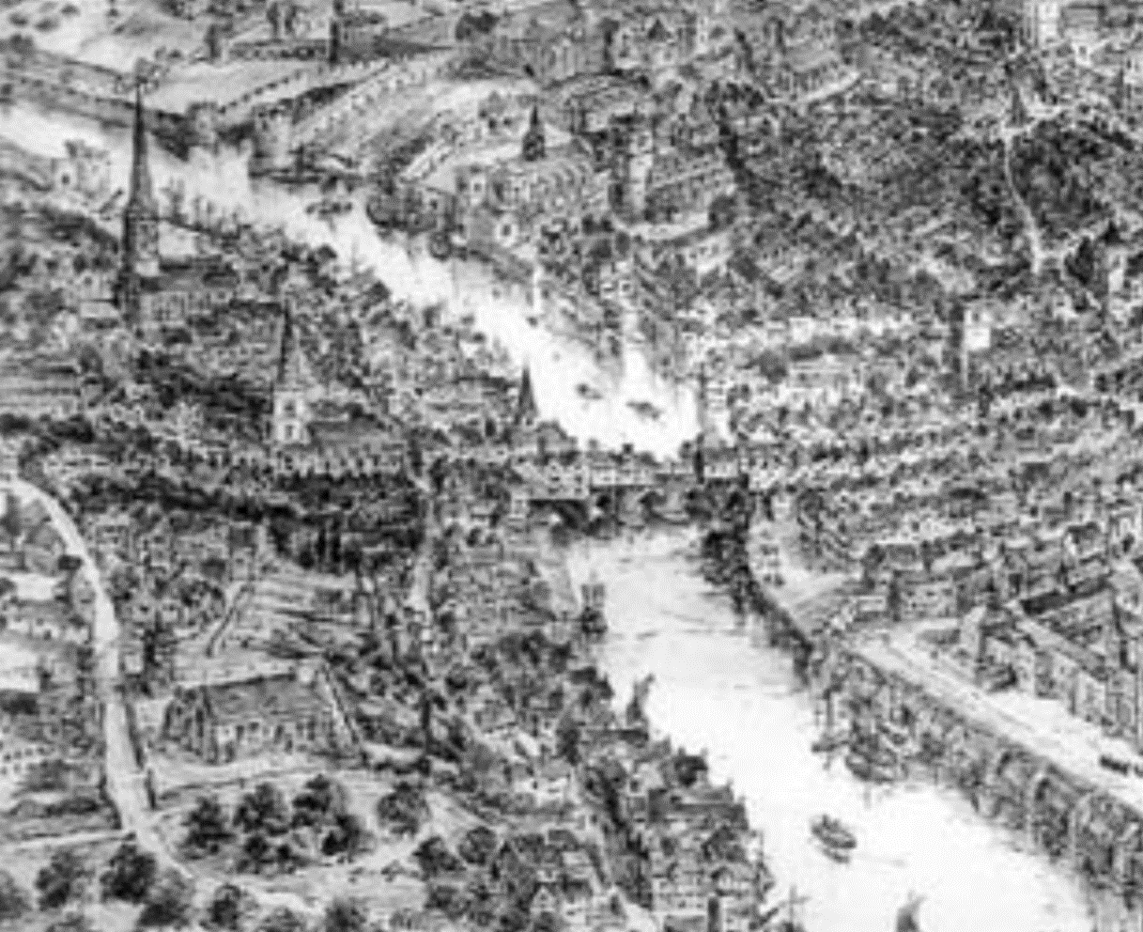
As we walk out of the church, the smell on Tanner Row is overwhelming; almost enough to knock the wind out of me. We are told by Master Blackburn that this is where the leather is produced, and that is apparent due to the smell. The leather trade makes up 30 percent of the 452 occupations in York. We can tell this is true as the street is very active, despite the fact that the tanners aren't working today.

The town is noticeably busier than when we entered the church earlier this morning and we are already struggling to navigate our way down the street. After fighting through the mass of people we end up on Ouse Bridge. I can smell the stench from the river but this is quickly drowned out by a nearer smell of animal fat. Looking around I find the source of the new smell; the candle shop, on the opposite side of the bridge. Ouse bridge is hemmed with shops and people, bustling in and out. There is every type of shop you can imagine and I am taken aback to see a prison and a small hospital among the shops. The bridge is even busier than anywhere else I have been and it is taking ages to get to the other side of the river.

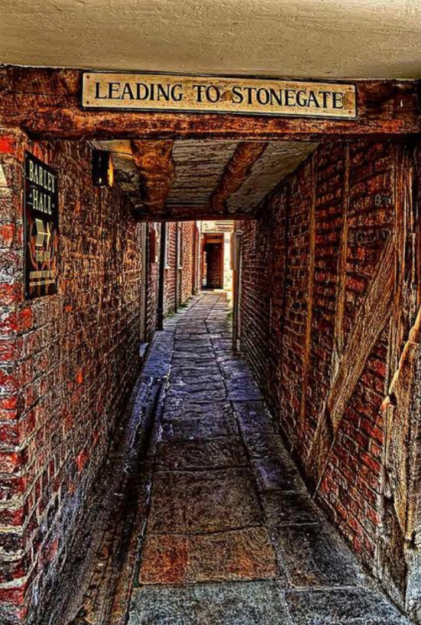
As we finally make it through the hordes of locals, I am dragged down a small alleyway and told by Master Nicholas that we won't get to our destination in time if we stick to the main and more busy streets. I am shocked by the sudden switch in atmosphere from the big, busy bustling streets to the quiet, narrow alleyways. We walk in single file as the stringy streets cannot hold our breadth.

The tall walls of houses climb up and over our heads creating a shadow which engulfs our bodies. Poorly built walls cram us into the small space. I regard Master Blackburn as together we watch, in disgust, people throw their waste and the contents of their chamber pots out onto the street. Master Nicholas is clearly annoyed by this as he grumbles something about how it's causing great disruptions and creates the appalling smell in the air. This is true, the smell of the alley is souring my nostrils and I wince at how unhygienic this area of the city is. To make matters worse, we are stopped momentarily in our tracks as we see a woman shouting for her purse, which has been stolen by a young boy with a dirty face and even dirtier feet.
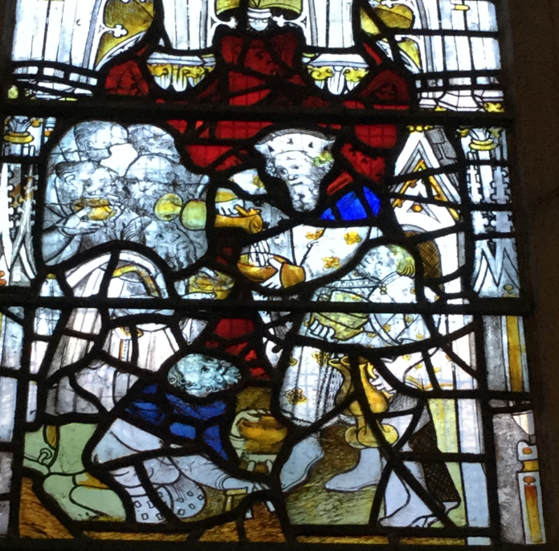
He can only be around 11 years old, a skinny little thing, his ecru shaded shirt is far longer and baggier than it should be. I am sure he has not been the only member of his family to wear that shirt. His dirty blonde hair whips and waves across his youthful face as he runs away from the decrepit lady. Her head swung low with self pity, she’s too old to chase after him, and due to the sagginess of the purse, it looks like it may have contained something precious.

I am told that his profession is not uncommon and neither is the beggar we can see to our left. He is crouched down on knee pads and with a modest sized stool to his side. He pushes his bowl out towards us and we throw a few coins into it. I become thankful as we get to the end of the alley, a sense of reassurance washes over me as we step out onto Pavement.
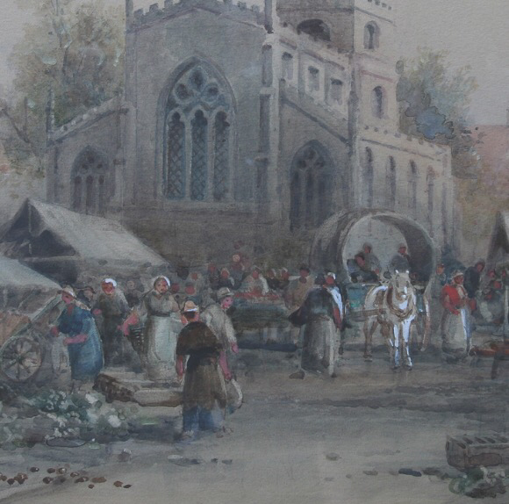
The new atmosphere is like a bio-polar universe. This is due to the date, 30th of May, 60 days after Easter, which means to everyone's joy it is time for the Corpus Christi Festival. I am told that people wait at their stations as different groups of people appear on their wagons to act out different part of the Corpus Christi plays. The surrounding houses have flowers peppered about on them to celebrate the day.

After a few seconds the enormity of the crowd distracts us from our thoughts, we are bombarded with people attempting to sell us food, drink and ribbons as they tell us that we are just in time to watch the tilers’ performance of the nativity. Master Nicholas’ face lights up with a child-like joy at the sound of that. A wagon pulls up near enough to us as the wagon bearers stumble into the middle of the square. Our view of the actors is not the greatest, but it is enough to make Master Blackburn’s little boy come out; he is so excited. I am told that the wagon bearers’ are paid in beer, but they are only half way through the performances and already looking the worse for wear. The wagon is a wooden flat-topped cart with four wheels and the playing area consists of the floor of the wagon, the ground in front of it and a raised area behind. The actors started the play in their elaborate costumes and everyone is pushing to try and get a view. I seem to be the only one who is amused by the the fact that baby Jesus is crying before he is born.
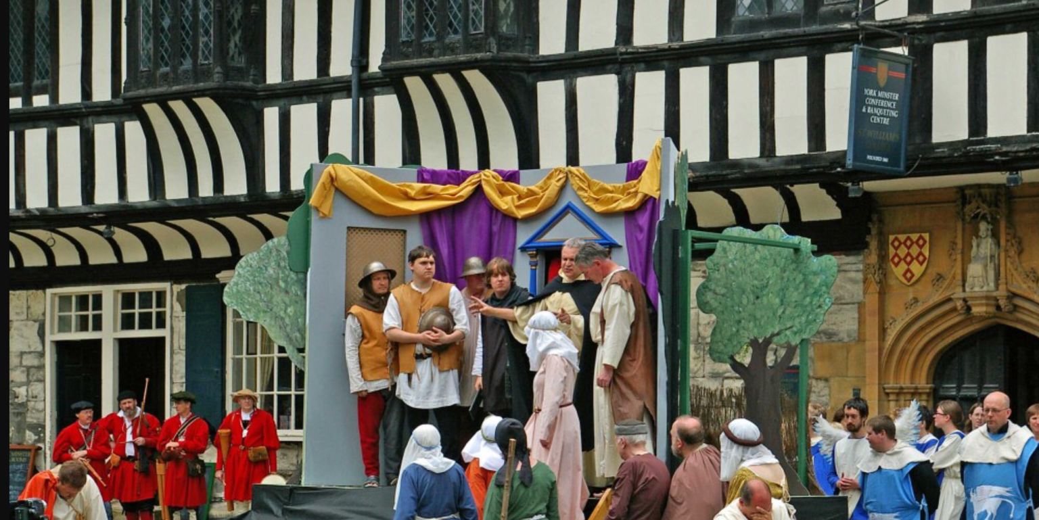

Who we are

This Time Traveller's Guide was put together by the 2016 Mount School History Creative Arts Festival Project group. We worked over two days to find out about our city in 1415. We visited key sites in the city, including All Saints' North Street and the Merchant Adventurers' Hall. This gave us a good sense of place and period. We have enjoyed working all together across the year groups and we hope you enjoy this booklet. It contains the text and images that we used for the presentations at the Creative Arts Festival showcase evening.

The members of the group:

Leah Cecily
Antonia Alice
Pietra Almu
Clare Eleanor
Charlotte C Coco
Charlotte H Neve
Jacqui Annabelle
Sophie

