HA Resource Hub Submission Form
Resource Title: Wharram Percy inference diagram |  |  | Age Range: 12-13
Author name and email contact:  Helen Snelson  enquiries@history.org.uk | Resource Details: (e.g. how many documents does it consist of? In which order?)  1 page of A4
Necessary prior learning to complete this:  Knowledge input of life in a medieval village eg by reading a textbook double page or watching a short film clip  Some basic knowledge of the role of this type of archaeologist and of historical illustration. |  | What does it lead to next?  Practises the link between sources (here finds) and historical interpretation, so builds evidential skills.  Knowing about life for the majority of English people in the middle ages sets students up for understanding society at the time of political changes in the middle ages and builds knowledge for understanding how life changed later – with rise of middle classes, larger towns, industrialisation etc.
Explanation: How should this resource be used?
To enable students to deploy knowledge they have read about / listened to / watched on the topic of a medieval village.

What do you think the archaeologist showed the artist?

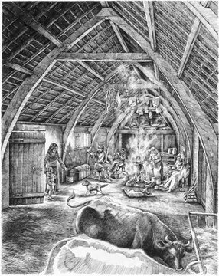
Excellent historians use evidence and imagination!

What does the artist show us?

