HA Resource Hub Submission Form
Resource Title: How is the ancient world relevant to me? |  |  | Age Range: KS3
Author name and email contact:  Helen Snelson  enquiries@history.org.uk | Resource Details: (e.g. how many documents does it consist of? In which order?)  13 sides of A4
Necessary prior learning to complete this:  None |  | What does it lead to next?  This sets up some key knowledge about the contribution of knowledge from the ancient world to later times, including our own. It also gets across the idea that knowledge is passed on and developed.  Students also get chance to work with an extract of historical scholarship and to think how it is constructed. The whole book is currently free on audible for the duration of this crisis and is easy access for children.
Explanation: How should this resource be used?

This is a one hour lesson that gives students some sense of the ancient world and its connection to our own times.
The first part of the activity uses an extract from EH Gombrich’s classic: ‘A little history of the world’ to hook students in. The opportunity is also taken to get students to think about the text as a work of history.
Then there are images of objects from the collection of the British Museum, with explanatory texts and a think question.
The final activity could be to write a page answer to the Q: ‘How is the Ancient World relevant to me?’ using the evidence.

Our enquiry question is: How is the ancient world relevant to me?

Read this extract from a book by a man called E.H. Gombrich. It is called “A Little History of the World” and he wrote it in 1935.
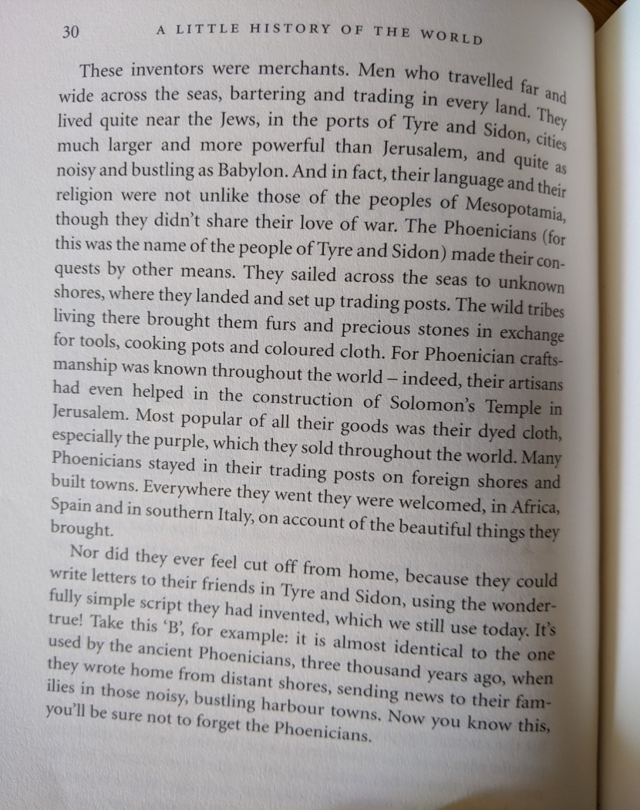
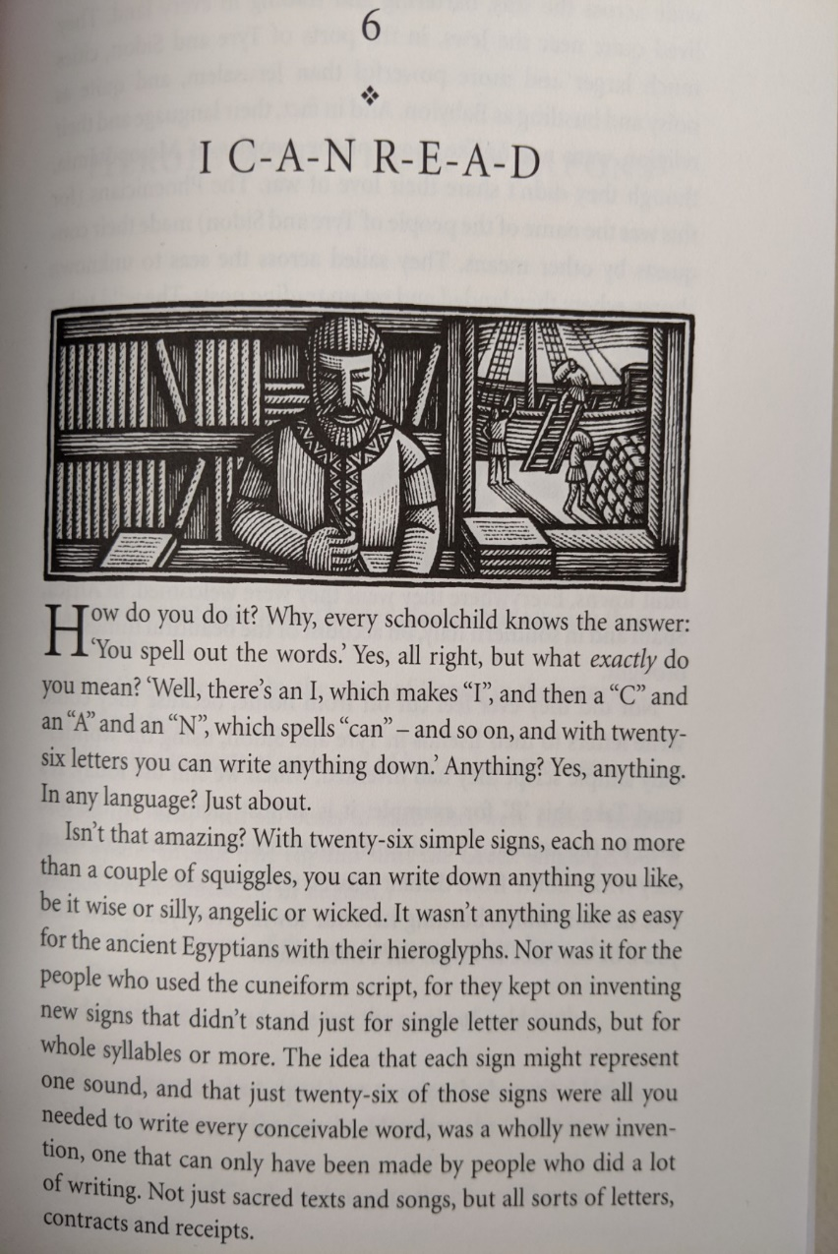
Historians have:
Opinions about the past.

These opinions are based on evidence.

Historians use sources in context as evidence.
History is:
Stories from the past.

Selected by historians…

…because they say something about today.

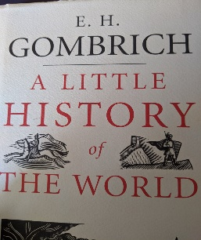

You might enjoy reading this book – or you can get it on Audible for FREE right now – so you could listen to is – it’s a classic!
TASK: Draw lines to the parts of the text which show each of these.

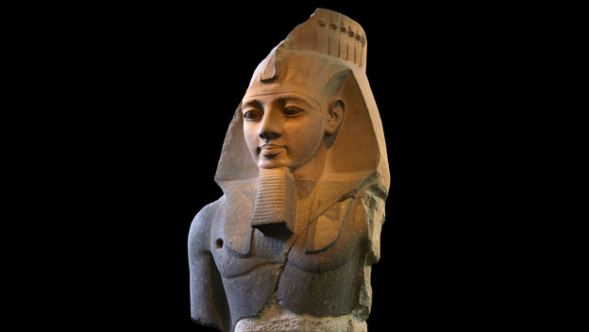

Statue of Ramesses II now in the British Museum in London
This statue of the Pharaoh Ramesses II of Egypt was designed to show him as a just and careful ruler, a mighty warrior and a living god. It was erected in the Ramesseum - his funeral temple, where the worship of Ramesses would continue for centuries. During his reign the annual Nile flood repeatedly reached ideal levels leading to good harvests and a period of prosperity in Egypt. Ramesses himself fathered 85 children with a number of queens during his 66-year reign from 1279–1213 BC .
Why was Ramesses II so successful?
Ramesses II is known as one of Egypt's greatest pharaohs - nine further pharaohs tried to emulate his success by taking his name. Although Ramesses was renowned as a warrior-king he suffered several military setbacks. Ramesses owed his reputation to his skills as a self-publicist - he erected more statues than any other Egyptian pharaoh. He even changed or added to the inscriptions on previous pharaohs' statues to glorify himself. This ensured that Ramesses was worshiped as a god for centuries after his death.
Think: is there anything that Ramesses did that people who rule still do today?

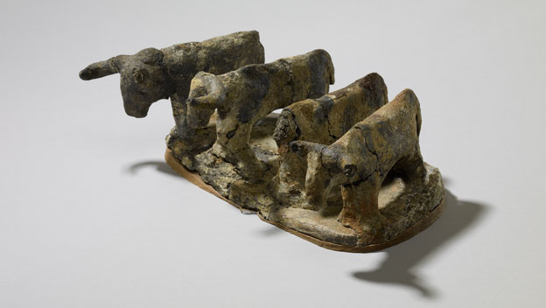

Egyptian clay model of cattle now in the British Museum in London
A model of four cattle buried in a grave in Egypt, African descendants of cows first tamed after the Ice Age.
This clay model of four cows was made in Egypt over 5000 years ago. It was placed in a grave, perhaps to provide its owner with food in the afterlife. Cows were revered in Egypt as a source of life in the harsh desert environment and whole cows were sometimes also buried with people. Later they were worshipped as the cow goddess Bat - the protector and mother of the pharaoh.
When were cows first domesticated?
Cows were first domesticated in North Africa in 8000 BC. After the Ice Age the earth had grown warmer and the lush savannah was transformed into the Sahara desert. As the climate became drier people became restricted to the Nile valley, where they relied on cows for food and as beasts of burden to carry water. Cows were also domesticated independently in the Middle East and today all cattle across the World are descendents of these Middle Eastern cows.
Think: how does this connect to the world today?

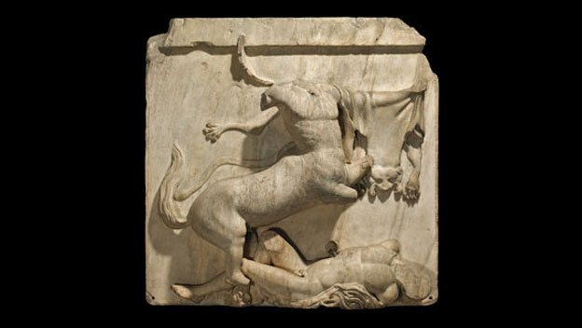

Parthenon sculpture: Centaur and Lapith now in the British Museum in London
Sculpture of a half-man, half-horse rearing over a dead human from the Parthenon in Athens, Greece.
This sculpture from the Parthenon shows a Centaur rearing triumphantly over a dying human Lapith. This focus on human suffering is typical of the intense humanism of Greek art. The sculpture also represents Greece's struggle to resist being absorbed into the Persian Empire. The Greeks had a strong notion of their own identity and regarded the Persians as barbarians like the Centaurs. The Parthenon was completed in 432 BC on the site of an earlier unfinished temple destroyed by the Persians.
What was the legacy of Classical Greece?
Victory over the Persians in 479 BC inspired a period of great creativity in Athens. This was the time of the philosopher Socrates, the playwright Sophocles and the statesmen Pericles. The wealth from Athens' Mediterranean empire funded the building of the Parthenon - an architectural testament to Athenian supremacy. Although Athens' golden age lasted for less than a century it was hugely influential. Greek ideas in drama, philosophy, literature, art, science and maths would dominate European thought for the next two millennia.
Think: can you imagine today’s world without the ancient Greeks? Why / why not?

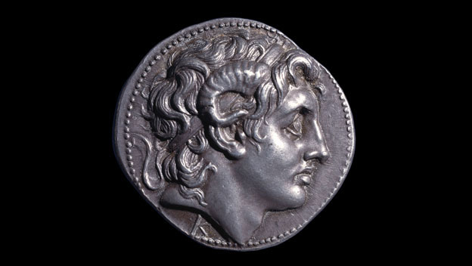

Coin with head of Alexander now in the British Museum in London
Coin showing Alexander the Great, issued by one of his successors.
This coin was issued by Lysimachus, the former general of Alexander the Great. After Alexander's death, Lysimachus ruled part of Alexander's empire in Bulgaria, northern Greece and Turkey known as 'Thrace'. Lysimachus used Alexander's portrait on his coins to emphasise his position as Alexander's successor. Alexander was worshipped as a god after his death. Here he sports the ram's horns of the god, Zeus Ammon, whom Egyptian priests claimed was Alexander's father. On the reverse of the coin is the goddess Athena.
Who was Alexander the Great?
Alexander was born in the kingdom of Macedon in 356 BC. By the age of 25 he had conquered Greece, Egypt and Persia, creating an empire spanning 2 million square miles. Following his death in 323 BC, Alexander's generals began to squabble over his legacy. Since they could not claim a blood-tie, these generals tried to legitimise their rule through other connections with Alexander. Eventually they divided the empire into three main kingdoms in Macedon, Egypt and Persia and went on to form powerful dynasties.
Think: how might Alexander have been an inspiration to Empire builders?

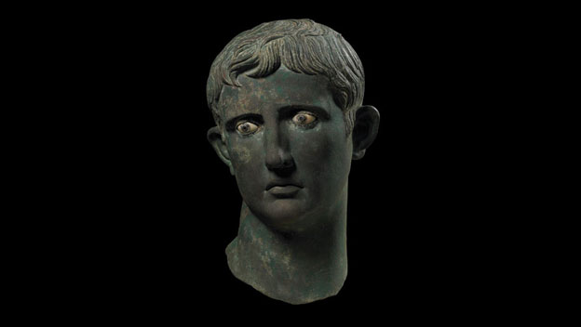

Head of Augustus now in the British Museum in London
Head of Augustus, the first Roman emperor, originally part of a statue in Egypt that was decapitated and buried in Sudan.
This head of the emperor Augustus was originally part of a statue in Egypt. The Romans used statues to remind the empire's largely illiterate population of the power of the emperor. Augustus is always depicted as a youth to reflect his strength and vitality. This head was decapitated by an invading army from Meroë in modern-day Sudan. They buried the head under the temple steps as an insult to Augustus. Ironically, it was this act of defiance that preserved the head.
When did Rome become an empire?
Augustus was the first emperor of Rome. He transformed Rome from a republic, led by competing nobles, to an empire, ruled by one man. In 31 BC Augustus defeated the armies of Mark Anthony and Cleopatra and made Egypt a part of the empire. Egypt's immense wealth helped Augustus to develop an effective army to expand and protect the empire's borders. The Roman Empire enjoyed a period of long-lasting peace under Augustus' reign. When he died he was declared a god by the Roman Senate.
Think: how does Ancient Rome bring Britain into our story of the ancient world?

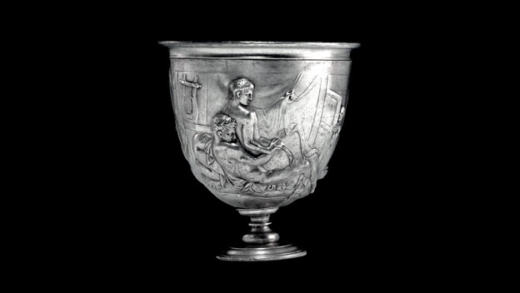

Warren Cup now in the British Museum in London
Silver cup used at Roman dinner parties decorated with pairs of male lovers, scenes not uncommon in Ancient Rome.
This luxurious silver cup was used at Roman dinner parties. The cup originally had two handles and depicts two pairs of male lovers. One side shows two teenage boys making love, while the other shows a young man lowering himself onto the lap of his elder, bearded lover. A slave-boy peers in voyeuristically from behind a door. The luxurious fabrics and musical instruments indicate that these scenes are set in a world heavily influenced by Greek culture, which the Romans admired and largely adopted.
What was the Roman attitude to relationships between men?
Images like this were not unusual in the Roman world. Some of the boys on this cup are underage by today's standards, but the Romans tolerated relationships between older and younger men. Relationships between men were part of Greek and Roman culture, from slaves to emperors, most famously the emperor Hadrian and his Greek lover, Antinous. Today such ancient images remind us that the way societies view sexuality is never fixed.

Think: how might Britain today have more in common with Ancient Rome than with Britain only in 1950?

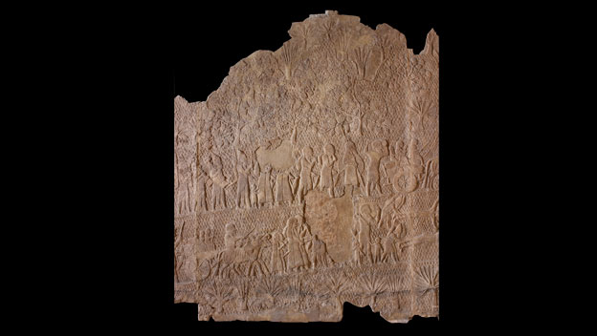

Lachish Reliefs now in the British Museum in London
Stone carvings from King Sennacherib of Assyria's palace, showing his army attacking the town of Lachish near Jerusalem.
The Lachish relief depicts the Assyrian army laying siege in 701 BC to the town of Lachish, about 40 kilometres from Jerusalem. Soldiers storm the town walls while prisoners are marched out of the town into exile. The relief was created for the walls of the great palace of the Assyrian king, Sennacherib, in Nineveh. Such scenes demonstrated the consequences of rebelling against the Assyrian empire. Sennacherib is shown as an invincible king presiding over a perfect victory.
Were the Assyrians war-like?
The Assyrians were renowned for their military successes yet they initially developed a strong army as a means to defend themselves. The Assyrian heartland has no natural defences and was vulnerable to attack. Soon the Assyrians had conquered an empire stretching from Egypt to Iran. Lachish was just one city that fell in a long series of wars that saw many people shifted from their homelands and put to work on such projects as building Sennacherib's palace.
Think: how many links can you find to the Bible in this extract?

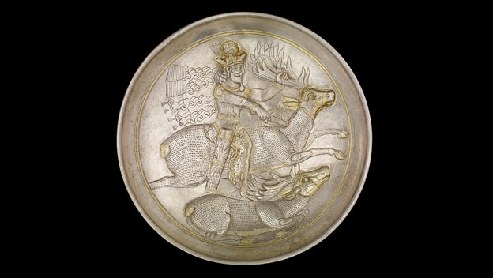

Silver plate showing Shapur II now in the British Museum in London
A plate showing Sasanian King Shapur II, who ruled Iran, Iraq and Afghanistan, and fought the Roman Empire.
This plate depicts a Sasanian king, probably Shapur II, leaping onto a stag and stabbing it in its neck. Sasanian kings were frequently portrayed as hunter-warriors, protecting their subjects from wild animals that ate their livestock or crops. Shapur II fought two long wars against the Roman Empire and, after killing the Roman emperor Julian, forced them to make peace with him. Shapur II also rigorously promoted Zoroastrianism, during the same period Christianity became the official religion of the Roman Empire.
Who were the Sasanians?
The Sasanians came from Iran and ruled a large empire from Iraq to Afghanistan from AD 224 to 622. They were the first Iranian dynasty to promote Zoroastrianism as the state religion. Zoroastrianism is the earliest religion to be based on a set of scriptures of the teachings of the Prophet Zoroaster or Zarathustra. The conflict between man and animal on this plate may reflect the struggle between good and evil that lies at the heart of Zoroastrianism.
Think: had you heard of the Sasanians before these lessons? Why do you think the Romans are more famous in Britain? How might things be different if you were at school in modern Iran?

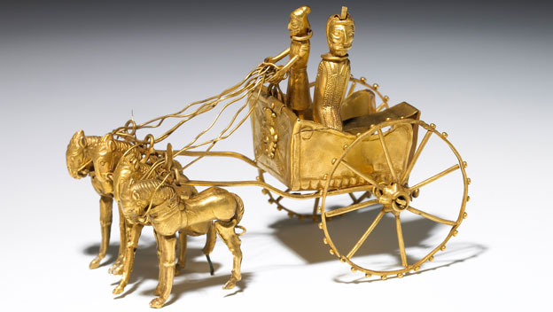

Oxus chariot model now in the British Museum in London
Model of a Persian chariot buried in a hoard from Central Asia.
This gold chariot comes from a hoard found near the Oxus river in Central Asia. It depicts a driver and probably a satrap - a governor of the Persian Empire. Satraps kept the peace, regulated the law and collected taxes in one of the empire's administrative provinces. The Persians built many new roads to enable communication and developed the first postal service. Religions freely intermingled in the empire and an image of the Egyptian dwarf-god Bes can be seen on the front of this chariot.
How was such a vast empire ruled?
Cyrus the Great transformed Persia from a small kingdom to the world's first superpower. The Persian Empire was the first to span three continents. Cyrus was a tolerant leader to those who submitted to his rule. He and his successors allowed their subjects to speak their own languages, practise their own religion and follow their own way of life. Rulers throughout history would be influenced by this 200-year period of Persian rule known as the Pax Persica (Persian Peace).

Think: what do you admire about this Persian Empire?

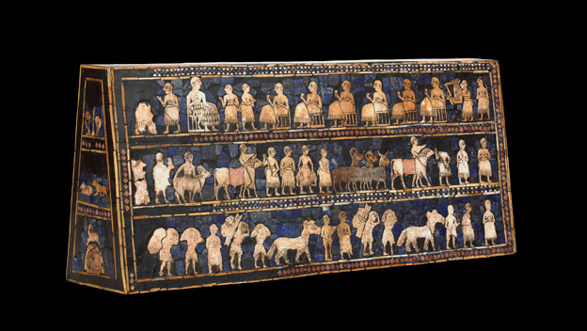

Standard of Ur now in the British Museum in London
The Standard of Ur is from one of the world’s first cities. It shows scenes from the life of a king of Ur in ancient Iraq.
What the Standard of Ur was used for remains a mystery but it seems to have royal connections. It was buried in a royal grave and depicts two contrasting scenes of a king of Ur - identifiable as larger than the other figures. On one side captured enemy prisoners are presented to the king by his soldiers. On the other side the king enjoys a ceremonial banquet accompanied by lyre music.
Where did the first cities develop?
Ur in Mesopotamia was one of the earliest cities in the world. The Greek word Mesopotamia means the land between the rivers and Ur was one of many cities that developed in the fertile plains between the Tigris and the Euphrates. Unlike Egypt at this time, these cities were not unified into a single state but were individual self-governing centres of power. They were ruled by kings and contained palaces, temples and sophisticated irrigation systems.

Think: what are cities for? Can you imagine a world without them?

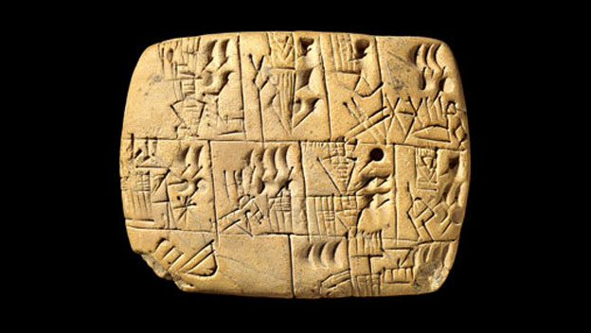

Early writing tablet now in the British Museum in London
Clay tablet from the ancient Middle East with some of the world’s earliest writing - a record of workers' beer rations.
This piece of clay contains some of the earliest writing in the world. It's called 'cuneiform,' which means wedge-shaped. This tablet is a record of the daily beer rations for workers. Beer here is represented by an upright jar with a pointed base. The symbol for rations is a human head eating from a porridge bowl. The round and semicircular impressions represent the measurements. All the signs were produced by a cut reed.
When did writing develop?
The oldest known example of writing comes from Mesopotamia and dates to about 3300 BC. In time different-looking writing appeared in the river valleys of Egypt, the Indus Valley, China and Central America. We cannot yet be certain whether writing spread from Mesopotamia, or developed independently in these civilisations. As Mesopotamian society became more complex, writing allowed administrators to keep an account of who had been paid and what had been traded. The earliest cuneiform tablets are almost all records of accountancy.

Think: how would your life be affected if writing had not been invented?

