|  |  |  |  |
| --- | --- | --- | --- |
| **HA Resource Hub Submission Form** | | | |
| **Resource Title: Intro to change 1700-1900** | | | **Age Range: KS3** |
| **Author name and email contact:**  Helen Snelson  [enquiries@history.org.uk](mailto:enquiries@history.org.uk) | **Resource Details: (e.g. how many documents does it consist of? In which order?)**  2 pages of A 4 | | |
| **Necessary prior learning to complete this:**  It’s the start of the 1700-1900 change topic, so makes sense to have some knowledge of Britain before 1700. | | **What does it lead to next?**  Sets up and understanding of the nature of the key changes in the period so that these can be investigated in more depth, including cause and consequence. | |
| **Explanation: How should this resource be used?**  It’s an exercise that students can use to answer the EQ: ‘What was the nature of change in Britain 1750-1900?’ It’s a straightforward intro for students to the nature and range of changes in the period known as the industrial revolution. They cut up the images with their captions and match them up 1750 on the LH column and c1900 on the RH column. They can then write a paragraph to answer the question using the images and captions. | | | |

1750: no one knew how disease was caused

By 1900: free primary education for all

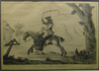

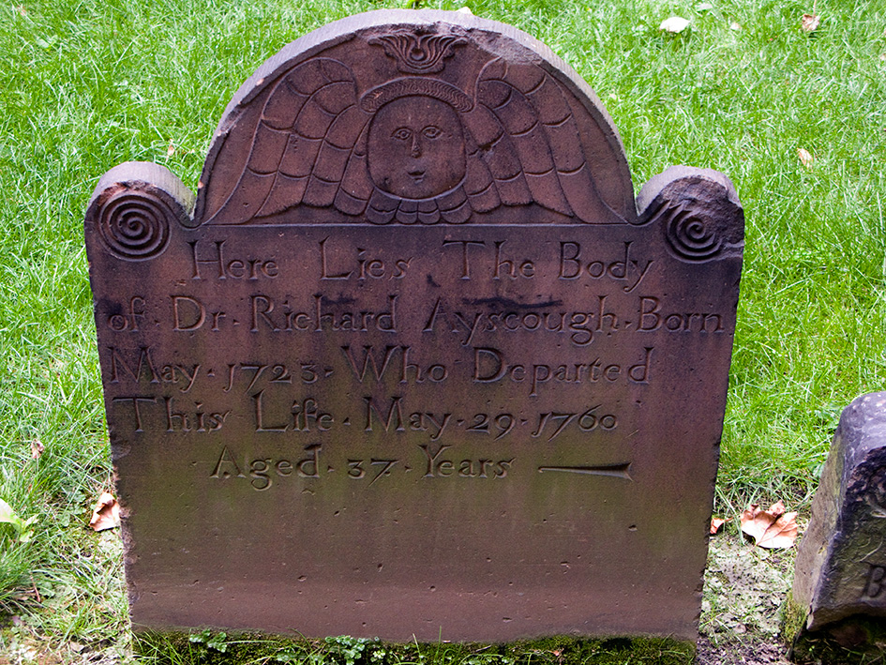

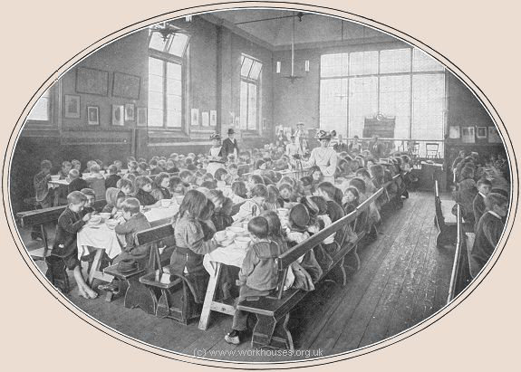

**Write the question ‘What was the nature of change in Britain 1750-1900?’**

**Match up the pictures (1/2 are from 1750 and ½ from 1900)**

**Then write a paragraph to answer the question.**

A street in 1750

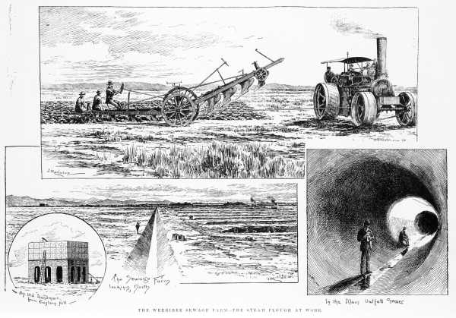

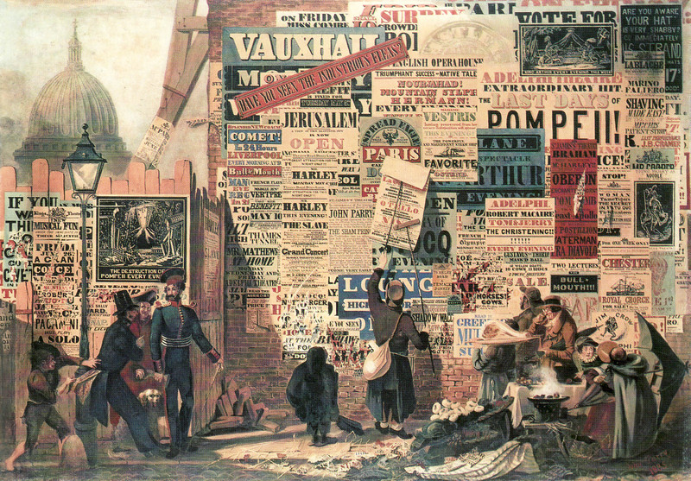

Steam machines made harvesting easier

Trains had revolutionised transport and communication

Post was delivered by courier to rich people

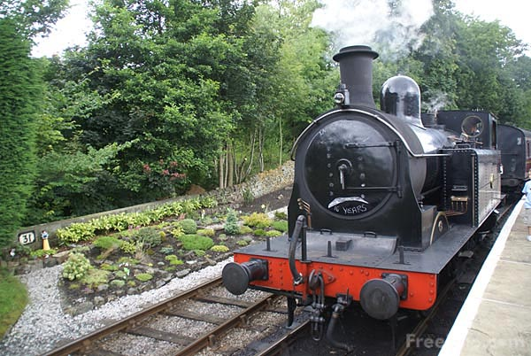

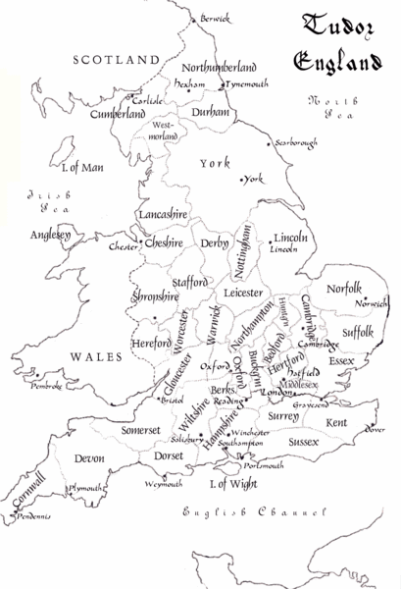

York was still one of the largest cities

By 1900 most people lived in towns and cities

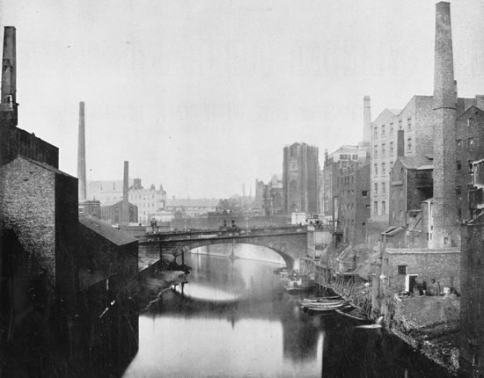

Steamships were larger and faster

Portraits were engraved or painted

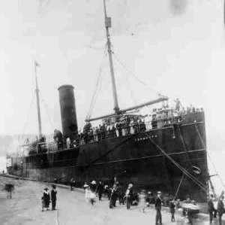

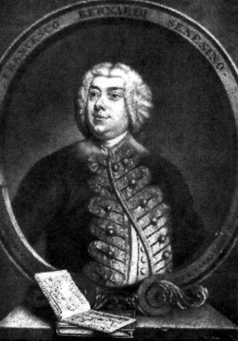

In 1750 wood was a very important power source

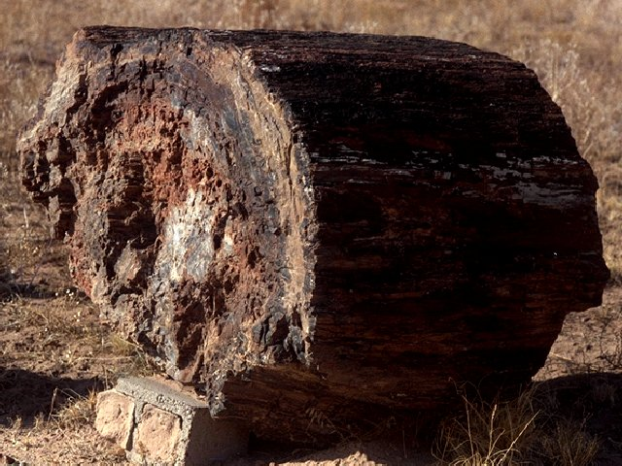

By 1900, Pasteur had developed the germ theory

Coal was crucial to the economy

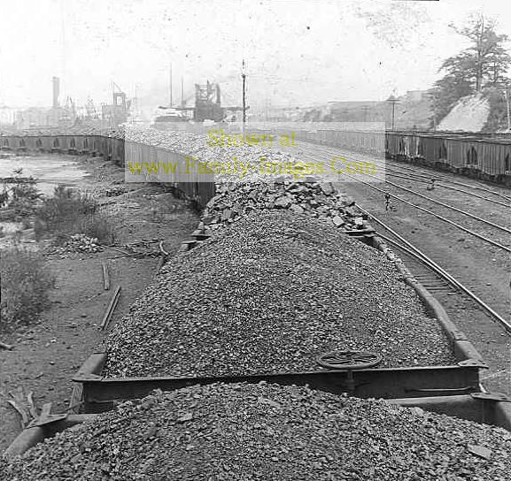

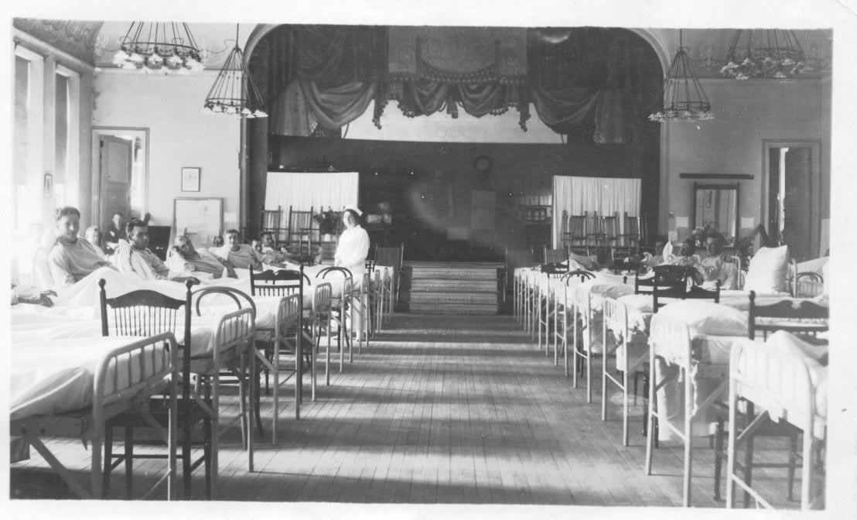

In 1750 horsepower was key to farming

The photograph had been invented!

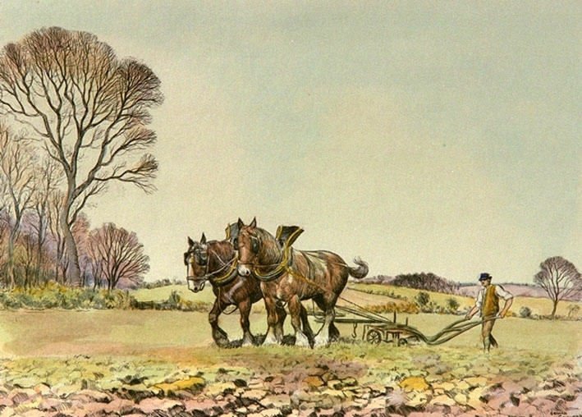

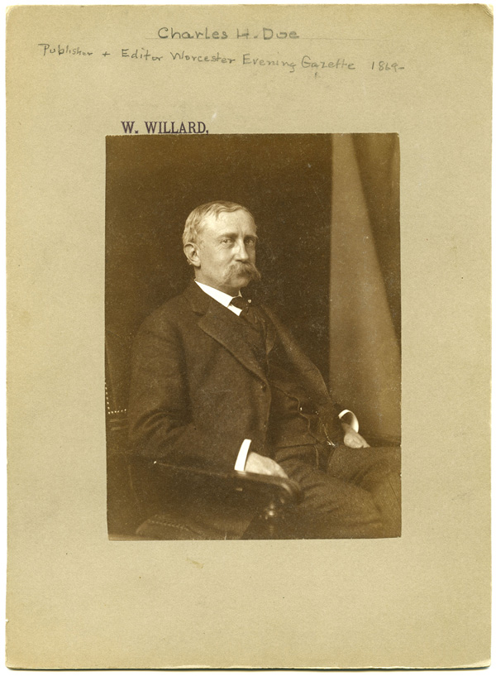

Education was mostly for rich boys

By 1900 there was a cheap and comprehensive postal service

Ships were made of wood and had sails

Transport was by boat, foot or horse

By 1900, most working men and all women still could not vote

In 1750 few, mostly rich, men could vote

In 1750 most people lived in villages

By 1900 most people worked outside the home

The population had increased dramatically

Most people worked at home

A street in 1900

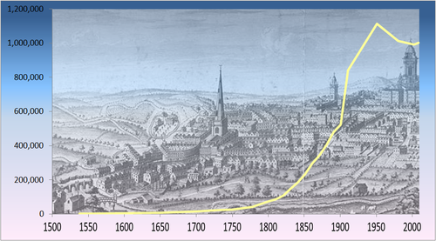

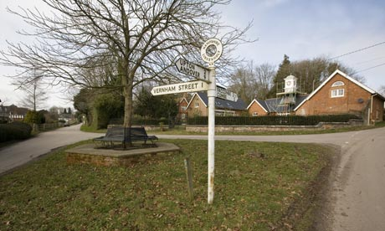

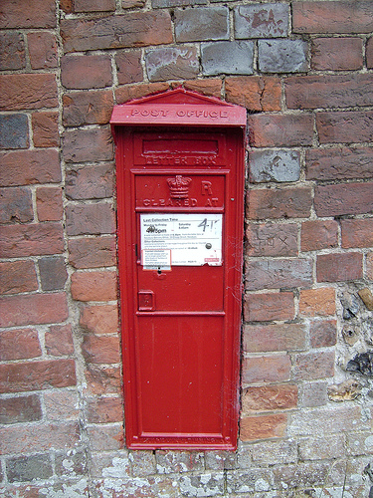

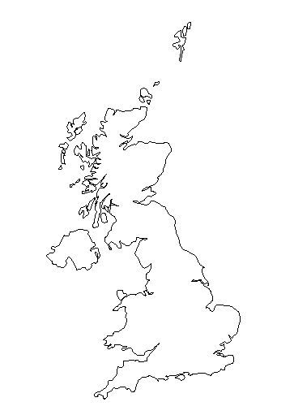

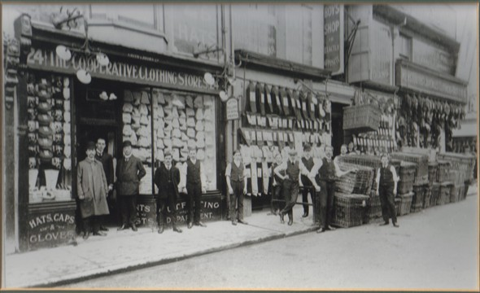



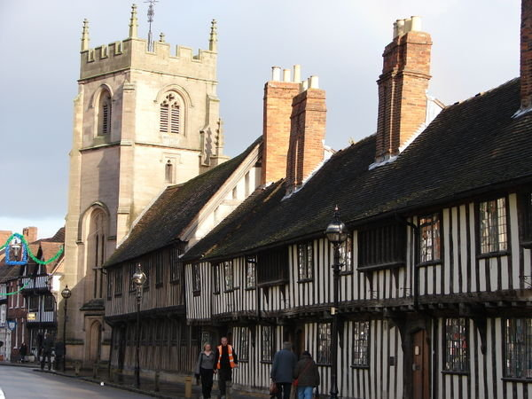

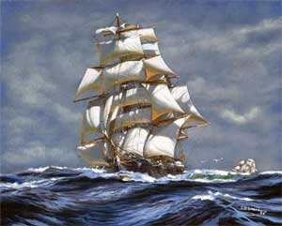

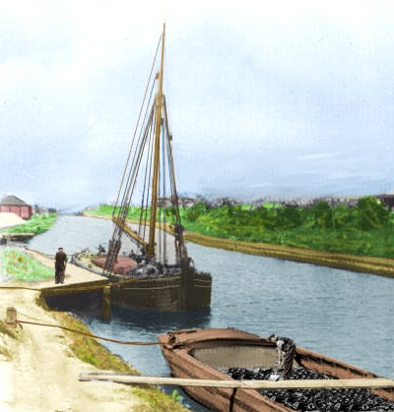

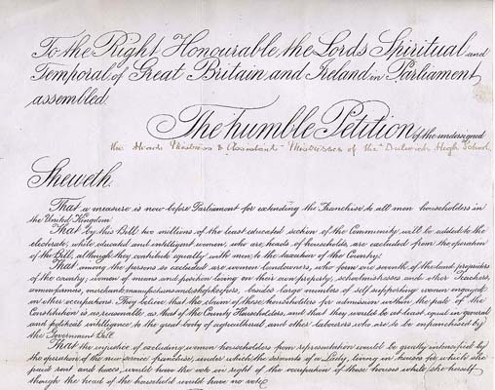

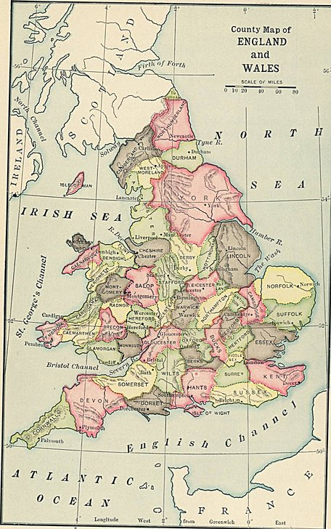

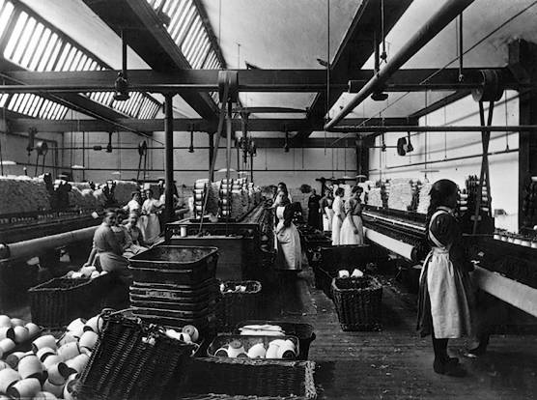

Britain in 1750

