HA Resource Hub Submission Form
Resource Title: Stone Age to Bronze Age |  |  | Age Range: Key Stage 2
Author name and email contact:  Alf Wilkinson  sue.alf@btopenworld.com | Resource Details: (e.g. how many documents does it consist of? In which order?)  One
Necessary prior learning to complete this:  An understanding of daily life during the Stone Age. |  | What does it lead to next?  Exploring the Bronze Age
Explanation: How should this resource be used?

Read the book.
Discuss the three bullet points. The first compares Stone Age life to life today; asking how similar and how different they are. This allows the children to move from the own life to daily life in a distant time. The second considers the impact of change – just how destabilising is the arrival of a new technology? [Again, comparison could be made with today...] How does the arrival of a bronze axe affect the community? Is change for the good, or bad? The third bullet point encourages the children to make a judgement about the author and the story. The story is now quite old, first published in 1968. Have our ideas of life in the Stone Age and Bronze Age changed since then, as more evidence has been discovered? Do modern accounts of the Stone Age and Bronze Age agree with the author? If that is the case, what would they change in the story?

Stone Age to Bronze Age

‘The Boy with the Bronze Axe’ by Kathleen Fidler is a story set in Scotland towards the end of the Stone Age. You can usually pick up second-hand copies online.

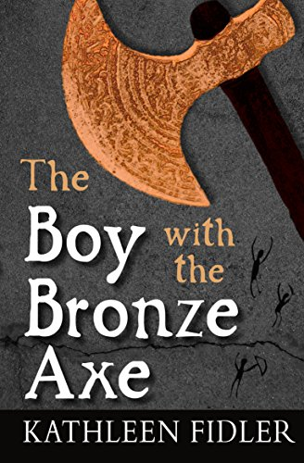

'The Boy with the Bronze Axe' is set in the Stone Age community of Skara Brae, in the Orkneys. The book is a great source of information about daily life, as understood at the time when the book was first published in 1968.

The story focuses on the lives of three children, Kali and Brockan, who live in Skara Brae; and Tenko, the boy with the bronze axe, who arrives in a dug-out boat the likes of which the folk of Skara Brae have never seen before. It is a story that will keep children gripped throughout.

Here are some things to think about after you have read the story:

- Similarity and Difference. Comparing life in the Stone Age with life today.

How similar are the lives of Kali and Brockan to your own? What do they do all day? What do they eat? Drink? Where do they sleep? Who would you rather be? Why?

- Continuity and Change. To what extent do things change once Tenko arrives, and to what extent do they stay the same?

Tenko arrives in a dugout canoe with a bronze axe. How does this affect life in the village? Does it make life better, or worse? How is a bronze axe different to a stone axe? Which things change as a result of Tenko’s arrival, and which things stay the same? Does everyone welcome the arrival of a bronze tool? Would you say the arrival of bronze in the village has a positive impact, or a negative impact? Why?

- Sense of Period. What was it really like to live in the Stone Age?

How realistic do you think the story of Kali, Brockan and Tenko is? Does it help you get a feel for what it was really like to live in Stone Age Britain? Do you think Kathleen Fidler has done her research? If you were writing this book, is there anything you would change? Why?

Alf Wilkinson, March 2020

