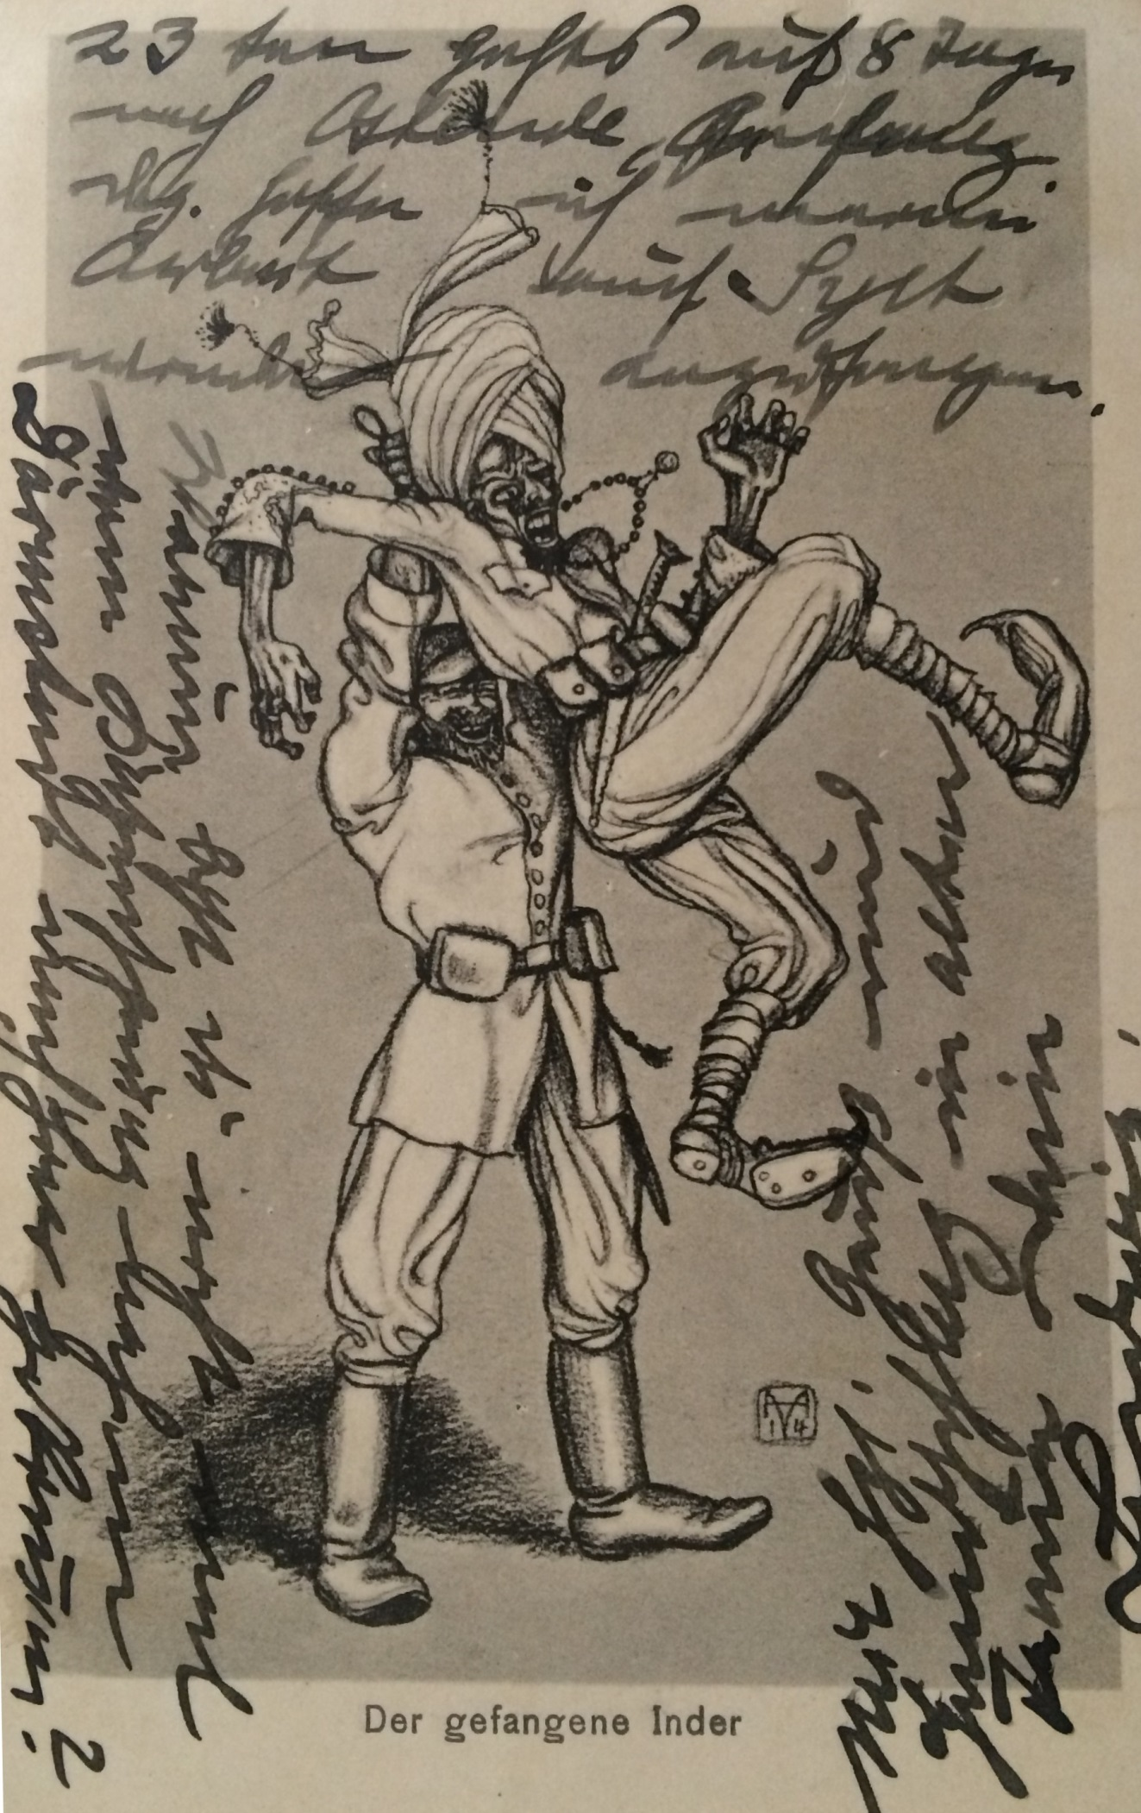
Image
A German postcard from early on in the war with an image of a German soldier holding a captured Indian soldier. The phrase “Der Gefangene Inder” translates as “The Captured Indian”.
By kind permission of Timothy Moore

