How were Sikh prisoners treated in the Half Moon Camp?
At the Half Moon Camp in Germany over 100 Sikh soldiers were held prisoner with other Muslim and Hindu soldiers from the British Indian Army.
The prisoners were treated well and allowed religious freedom. They had to listen to anti-British propaganda encouraging them to fight for Germany and unite with other Indian soldiers to found an independent India, free from British control. Newsletters were printed in Indian languages but these probably did not have much effect as most Indian soldiers could not read. German attempts to recruit Indian soldiers mostly failed.
German scientists and researchers were excited by having so many non-Europeans on German soil to study (ordinary Germans also liked to organise outings from Berlin to stare at what seemed to them these strange people in the camps, rather like viewing animals in a zoo.) The Half Moon Camp was like a laboratory. A German scientist was fascinated by the Sikh prisoners in particular. They were painted, drawn and photographed accurately. In a separate study the prisoners were recorded talking in their own languages. Their bodies were measured carefully. Their faces recorded, noting the colour and shape of their eyes and nose. The strength of the Sikhs was also tested through nail-biting and hand-gripping.
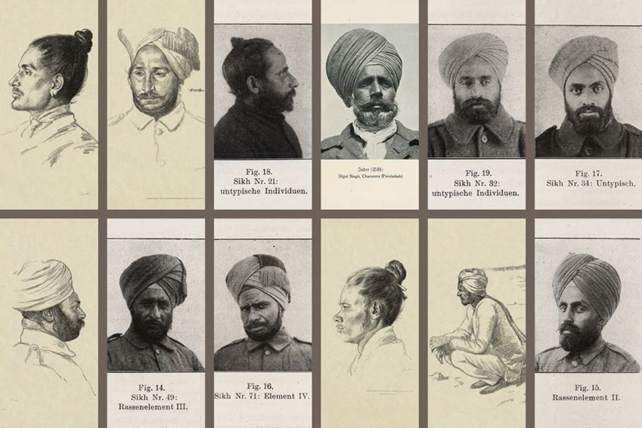
1. Some of the Sikh prisoners of war who were examined by a German scientist. (UKPHA Archive)
Family details were noted and even tattoos on the skin. But why go to all this trouble?
Like the British and most other Europeans at the time, the Germans believed that non-Europeans with different skin colours were inferior to white Europeans. They believed that there were different “races” in the world. By studying people carefully scientists and researchers would be able to understand why different peoples belonged to different “races” and explain why some peoples (like the Sikhs) seemed better at fighting.
Most Germans thought it was very dangerous for Britain and France to bring their non-European (i.e. African and Asian) troops to fight against white Germans in Europe. They thought it might help to prove that white Europeans were not superior after all. If white Germans (who many Germans had no doubts were the best soldiers in the world) could be defeated by non-white Europeans what would happen to European empires outside Europe? Might non-Europeans get the idea that they could rule themselves? (It didn’t bother the Germans that they were trying to stir up Indians against the British who were also white Europeans.)

