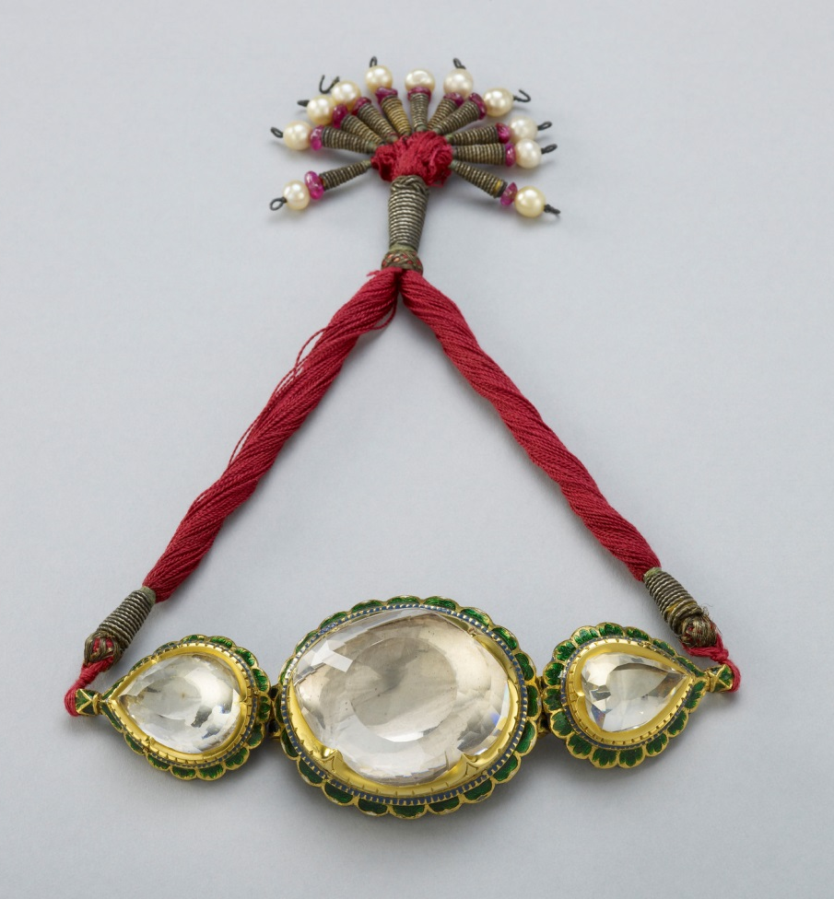
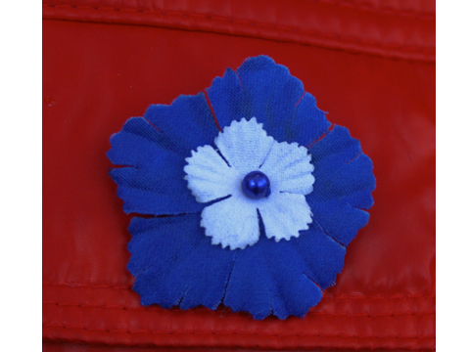
Image 1 (top)
The Koh-i-noor (Persian for ‘Mountain of Light’) diamond in its original setting. It was confiscated from the Sikh State by the British East India Company after the Second Anglo-Sikh War in 1849 and subsequently presented to Queen Victoria. In England, it was cut down to almost half its original size in an attempt to make it more attractive to European eyes.
Royal Collection Trust/© Her Majesty Queen Elizabeth II 2014

Image 2 (bottom)
A cloth cornflower worn as a symbol of remembrance in France for French soldiers who died during the First World War.

