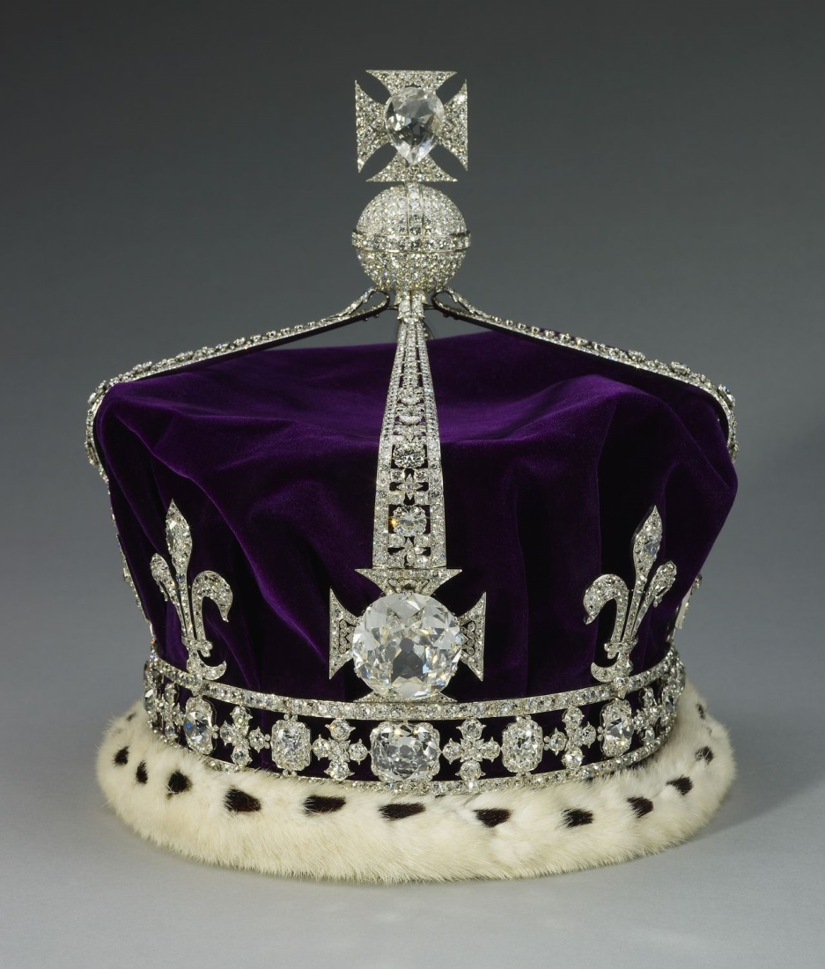
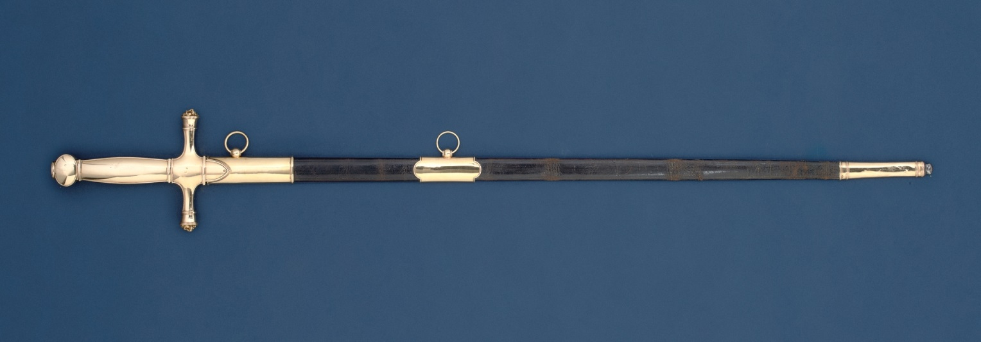
Image 5 (top)
The sword of the Duke of Wellington previously belonging to Napoleon the First and given by Wellington to Sir Henry Hardinge, British Governor-General of India. The inscription on the blade reads: “This SWORD was worn by THE DUKE of WELLINGTON from his entering into PARIS July 1815 to 1817”. Hardinge sent this sword off the battlefield for safe keeping with his son during the Battle of Ferozeshah in 1845 when his forces faced defeat by the Sikh army.
The Wellington-Hardinge sword, 1809 (metal), Biennais, Martin Guillaume (1764-1843) / Private Collection / Photo (c) Christie's Images / Bridgeman Images

Image 6 (bottom)
A replica of the crown of the late Queen Mother, with the Koh-i-noor diamond set within it. The historic Koh-i-noor diamond was one of the most precious treasures of the Sikh Kingdom, which was taken over by the British East India Company following two battles in 1846 and 1849. From the time of its gift to Queen Victoria it has formed part of the British Crown Jewels and by tradition is only worn by women.
Royal Collection Trust/© Her Majesty Queen Elizabeth II 2014

